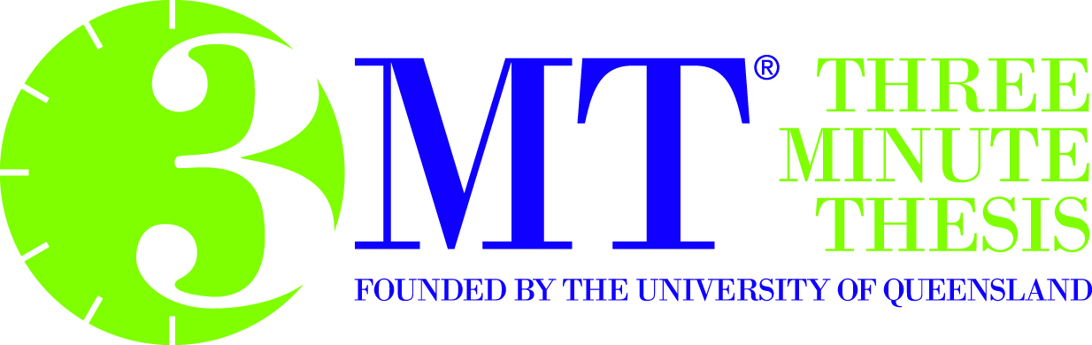
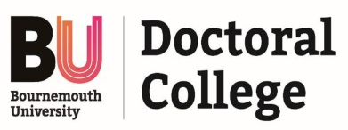
3MT® Application Form 2017-2018
Full Name and Faculty:
Type of research degree: Have you passed your transfer exam and date:

Email: Contact number:
3MT® Guidance
Your 3MT® application should clearly outline the significance of your research project, specifically highlighting the impact it makes on your field/discipline, any societal, practice or policy impact and the unique contribution the research makes to knowledge. Your 3MT®can be on any aspect of your research but should be clear and concise and avoid the use of specialist and or technical terminology, making the application understandable to all.

3MT® presentation rules
- A single static PowerPoint slide is permitted. No slide transitions, animations or 'movement' of any description are allowed. The slide is to be presented from the beginning of the oration.
- No additional electronic media (e.g. sound and video files) are permitted.
- No additional props (e.g. costumes, musical instruments, laboratory equipment) are permitted.
- Presentations are limited to 3 minutes maximum and competitors exceeding 3 minutes are disqualified.
- Presentations are to be spoken word (e.g. no poems, raps or songs).
- Presentations are to commence from in front of the audience.
- Presentations are considered to have commenced when a presenter starts their presentation through either movement or speech.
Title of your 3MT®:

3 Keywords for your 3MT®:

Outline the content of your 3MT® (150 words):

Why do you want to take part in this 3MT® competition?

Once completed please submit the application via email to PGRskillsdevelopment@bournemouth.ac.uk. Please note that there are only 20 spaces for this competition. You will be informed if you have been unsuccessful or successful in this shortlisting to progress through to either Heat 1 or Heat 2 during week commencing 6 November 2017.

