Members of the SUBU Arab society holding a cut out Instagram photo frame
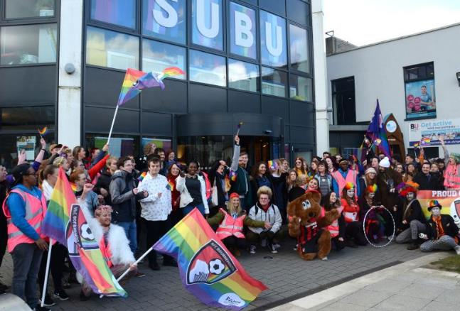

Disabled conductor James Rose being awarded an honorary degree from BU, in recognition of his achievements in music and his work to champion disability rights.


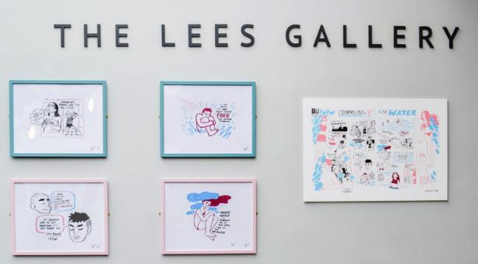

A couple of women sitting in chairs in the new Student Retreat. 



Artwork on display at the bodyworks exhibition. The neon sign intersects two words,  'BRAVE' and 'TRAGIC'. 
The bodyparts exhibition brings together a diverse collection of artworks to explore the hypervisibility of disability through the coverage of the Paralympic Games and the impact this has had on the everyday lives of disabled people.


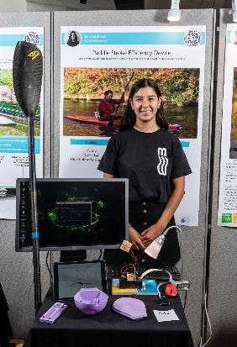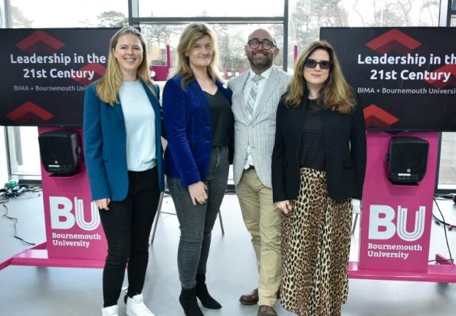

# **Equality, Diversity and Inclusion Annual Report**

**2022-2023**

# **Foreword**

This annual Equality, Diversity and Inclusion (EDI) report celebrates achievements and progress made in relation to BU’s progress towards embedding equality, diversity and inclusion and covers the calendar year 2023.

Inclusivity is a core value that underpins the BU2025 strategic plan, and our vision is that this is a community and culture built on respect, compassion and curiosity where our staff and students feel they belong and can thrive. Delivering on the promise of our value of inclusivity is one of the ways that we will enrich society.

Talent comes from all corners of society, and we understand the value that diversity of people, perspective and experience bring to our ability to deliver creative, innovative and high-quality research, teaching and services.

We are proud of our increasingly diverse and inclusive community and the progress we have made this year, including our first Race Equality Charter bronze award; successful reverse mentoring pilot; largest Aurora cohort of 28 women; new Menopause support network; and pioneering university retreat to support student mental health.

We recognise that embedding EDI requires continued and sustained cultural change and we work to take action to address gaps and challenges in equality, diversity and inclusion in order to support development, progression and achievement for all.

In 2023, we are harnessing this opportunity to take stock of our current approach to EDI, how we further engage the wider community in the EDI agenda, better align resources for a strategic and intersectional approach, and move closer towards our ambition that EDI is ‘BU owned, HR enabled’. Underpinning our ambition is a recognition of the importance of individual and collective agency and accountability.

The continuing work includes a proposed new EDI governance approach and equality objectives.

The report recognises an enormous amount of work from our partners and colleagues who are committed to ensuring our community is inclusive and welcoming, thanks to all for their support and positive impact to this agenda.

**Karen Parker**

**Director of Human Resources**

# 

# **Context**

This report provides an overview of the work undertaken during 2023 to promote equality, diversity and inclusion (EDI) across BU. Our EDI Annual Report plays an important role by helping us to continuously measure and share our progress going forward.

This report also outlines how BU is meeting the requirements of the Equality Act 2010 and Public Sector Equality Duties. In accordance with our obligations under these we are required to:

* Have due regard to the need to:
  + Eliminate unlawful discrimination, harassment and victimisation and other conduct prohibited under the Act.
  + Advance equality of opportunity between people who share a protected characteristic and those who do not.
  + Foster good relations between people who share a protected characteristic and those who do not.
* Publish gender pay gap data by 31 March every year.
* Publish one or more equality objectives at least every 4 years.

It should be noted that this annual report does not seek to capture the totality of EDI work across BU during this year; this is already covered in detail through ongoing initiatives and our various equality charter submissions and action plan deliverables. These include our Access and Participation Plan, Gender Pay Gap Report and Action Plan and our Race Equality Charter submission. The report summarises major milestones and key achievements during the year, highlighting areas of strength, as well as those that still require focus and attention.

* Key EDI statistics for the year are appended.

## 

## EDI Governance

* 1. The EDI Committee (EDIC) is focussed on ensuring that the strategic vision for EDI is achieved and that we are fulfilling our legal responsibilities. In 2023, the terms of reference and membership were updated to increase membership, representation and effectiveness.
  2. Three new EDIC sub-committees have been established to focus attention and drive further progress:
* **Inclusivity Actions EDIC sub-committee**: To help better align and consolidate the breadth of work and review, and ensure implementation of, equality and inclusivity actions (circa.400) across BU.
* **Events and Communications EDI sub-committee**: We have co-built one communication plan that is accessible to our entire community on the BU website to capture and promote activity and encourage collaboration, between our staff and students, on national campaigns, and to support engagement in the wealth of events, learning and resources available.
* **Language EDIC sub-committee**: Working in collaboration with our community to further adopt inclusive language into our everyday practices and communications.
  1. As we further engage the wider community, and mature our approach, we are establishing:
* **New Senior ULT Diversity Champions:** Aligned to different diversity agendas and acting as visible champions and advocates.
* **Inclusivity Facilitators**: Aligned to each faculty and department, working with the leadership team and central EDI team, to champion and advance EDI effectively at a local level.
* **Staff Network Co-chairs**: To help lead and guide our staff diversity networks and advance equality conversations at BU. Staff network co-chairs will receive allocated protected time, annual budget and support from the senior diversity champion and central EDI team to help them to be effective in this role.

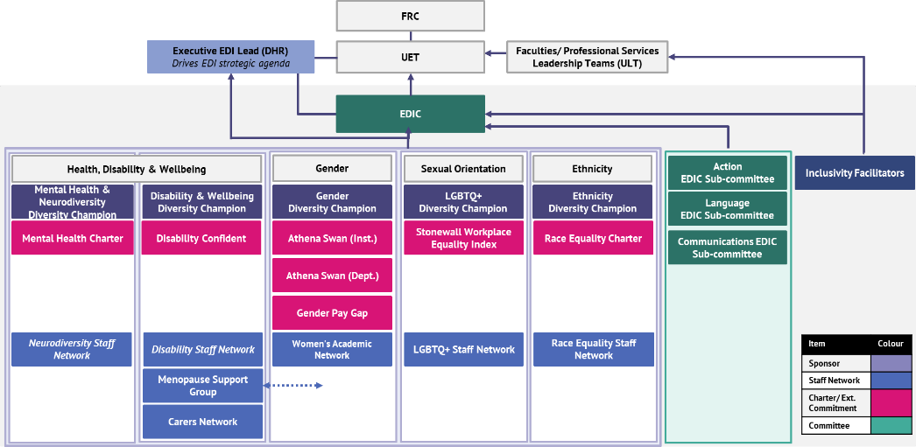

**Figure 1.1:** An overview of BU’s Equality, Diversity and Inclusion governance framework.

1. Delivering Progress through our Equality Charters and Action Plan Promises, and Maximising Synergies to Better Align Resources and Increase Impact of Actions
   1. BU is committed to several 'Equality Charters' related to equality and inclusion.
   2. Our Equality Charter commitments help us to identify and tackle organisational and cultural barriers standing in the way of equality for specific groups of staff and students.
   3. We are committed to delivering our action plan priorities and, in 2024, we are seeking to identify and maximise synergies between the charters and the multitude of actions resulting from them, grouping them by themes and clarifying ownership. This will make it easier to understand how the work of the charters is inter-connected to help better align resources, create opportunities for collaboration and embed work into ‘business as usual’.
   4. The implementation of action plans and the need to maintain our various charter award levels is significant for the University’s reputation as an inclusive educator and employer, but also comes with substantial resource demands. Key stakeholders from the BU staff and student community support the planning and delivery of the self-assessments and action plans.

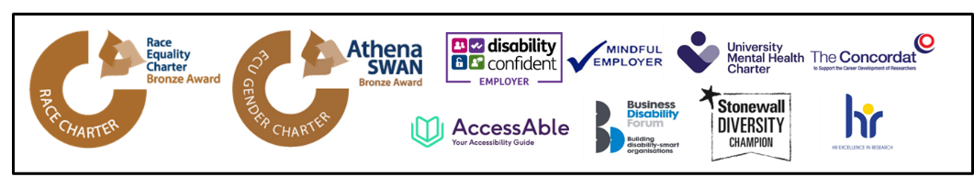

**Figure 2.1:** BU commitments: Race Equality Charter (bronze), Athena Swan (bronze), Disability Confident Employer, Mindful Employer, University Mental Health Charter, The Concordat, AccessAble, Business Disability Forum member, Stonewall Diversity Champion and HR Excellent in Research.

* 1. **Race Equality Charter: Inaugural Submission Awarded Bronze in July 2023**
  2. The Race Equality Charter’s mission is to improve the representation, experience, progression and success of minority ethnic staff and students within higher education. We cannot reach our full potential unless we benefit from the talents of our whole community, and until all individuals from all ethnic backgrounds can benefit equally from available opportunities.
  3. In July 2023 Advance HE awarded BU a bronze award, in recognition of our ongoing commitment to tackling racial inequalities. Developing solutions to racial inequalities and achieving long-term institutional culture change is complex and will only be delivered with the collective and concerted effort from the whole University community.

**Professor John Vinney, BU Vice-Chancellor, 2010 to August 2024**

“I am very proud of our success. I know that it has taken a lot of hard work by many colleagues across BU and SUBU. I want to thank everyone who was involved and helped us reach this award through their dedication and commitment.

We remain committed to progressing with our work in this area and an environment where all staff and students can flourish. We recognise that there is still much to do to live our value of inclusivity and deliver the implications for our BU community. We have defined our organisational purpose as to inspire learning, advance knowledge and enrich society. Delivering on the promise of inclusivity for all is one of the ways in which we will enrich society.”

* 1. **Athena Swan: On-going Delivery of the Institutional Action Plan and Championing Gender Equality and Inclusion at Local Level through Departmental Athena Swan Groups**
  2. The Athena Swan Charter recognises good practice in promoting gender equality in higher education and, at BU, we have held an institutional Athena Swan Bronze award since 2015.
  3. Since our renewal in 2018, we have made significant progress against the institutional action plan and there are several areas of success and achievement, as well as several actions that would benefit from additional work. Considering this,and following the departure of key members of the self-assessment team, we have extended our submission date from November 2023 to November 2024, enabling us to accelerate progress against key actions and collect additional evidence of impact to strengthen our application.
  4. BU2025 aims for departments to have achieved an Athena Swan award by 2025 and the work of departmental Athena Swan leads is rewarded and accommodated through workload allocation. Five departments now hold a local Athena Swan award; Media Production; Archaeology and Anthropology; Design and Engineering; Life and Environmental Sciences; and Psychology.
  5. **Disability Confident: Exploring Advancing from Disability Confident Employer to Disability Confident Leader Status**
  6. We are a Disability Confident Employer, a quality mark awarded by the Department of Work and Pensions for our positive commitment to the employment, retention, training and career development of disabled employees.
  7. We are also members of the Business Disability Forum (BDF) and work with BDF to ensure that our policies and services are accessible and inclusive. In the next academic year, we will work closely with BDF towards Disability Confident Leader accreditation.
  8. Additionally, as members of AccessAble, staff and students have access to detailed accessibility information about all the university’s campuses, buildings and facilities.
  9. We have seen an increased number of staff seeking assistance with existing or emerging neurodivergent conditions. Working with Additional Learning Support, we can refer staff members for in-house screening, with onward referral to Educational Psychologist appointments, where indicated. This provides us with detailed information regarding reasonable adjustments so that we can support both staff and students.
  10. We also delivered two bespoke Faculty workshops focussed on developing an understanding of neurodiversity and disability, challenging misconceptions, and identifying practices which help neurodivergent people flourish in the workplace and create a culture which values thinking differently. We are exploring further development of resources in 2024.
  11. **Mental Health: Signed up to the University Mental Health Charter (MHC)**
  12. Building on our commitment as a ‘Mindful Employer’, we have signed up to the Student Minds ‘University Mental Health Charter’. We have established the MHC steering committee and begun our self-assessment and we are working with Student Minds to agree the timeline for assessment and submission.
  13. The University Mental Health Charter framework provides a set of evidence-informed principles to support universities to adopt a whole-university approach to mental health and wellbeing to create lasting positive change for staff and student mental health.
  14. **HR Excellence in Research Award and UK Concordat to Support the Career Development of Researchers: Renewed** [**HR Excellence in Research Award**](https://www.vitae.ac.uk/policy/hr-excellence-in-research) **in 2023 and Celebrated a Decade of Commitment**
  15. BU successfully retained the [HR Excellence in Research Award](https://www.vitae.ac.uk/policy/hr-excellence-in-research) for a tenth year in 2023. BU is one of three institutions to retain the award after their 10-year review.
  16. Our research staff are integral to the success of BU and the award demonstrates BU's long-term commitment to supporting the career development of our research staff, developing policies to support researcher development, and providing space to empower our research staff to impact their careers.
  17. Key achievements highlighted in our ten-year submission include providing Bridging Funding to enable research staff on fixed term contracts to remain in post while awaiting the outcome of future funding applications, and creating 12 new research posts within high-performing academic teams as part of the [Research Capacity Transformation Scheme](https://www.bournemouth.ac.uk/news/2022-12-07/research-capacity-transformation-scheme-investing-research-teams-future).

Equipping and Empowering our Leaders to ‘Lead Inclusively’

* 1. We have invested in our leadership teams to strengthen the inclusive leadership capabilities of our managers. Understanding and being adept at inclusive leadership will help our leaders thrive in an increasingly complex and diverse environment. The research also shows us that what leaders say and do makes up to 70% difference as to whether an individual reports feeling included, and teams with inclusive leaders report higher performance, better decision making, greater collaboration and reduced absenteeism[([1])](#_‘Why_Inclusive_Leaders).
  2. **Reverse Mentoring: Successful Pilot Delivered**
  3. Senior leaders were mentored by individuals from different minority ethnic backgrounds. The scheme was designed to give mentors an opportunity to share insights and experiences and build cross-institutional relationships. The initiative also offered mentees a fresh perspective on BU’s culture and an opportunity to build genuine awareness of the lived experience and barriers faced by staff from a Black, Asian or minority ethnic background.
  4. The 16 attendees included our Vice-Chancellor, evidencing genuine commitment from our leadership team to listen and learn and to take action to address barriers and enhance inclusivity at BU.
  5. Feedback shows that this was a valuable and insightful experience, with attendees committing to keeping in touch and expanding the conversation with the wider BU community, for example, through podcasts. In 2024 we plan to expand this initiative, furthering impact.

**Sophia Amenyah, Postdoctoral Research Fellow and Reverse Mentoring Scheme Mentor**

“It’s important to share your lived experiences, so that these can influence the university policy and create a more welcoming and productive workplace culture and environment.”

“[I found value in] understanding a different perspective and hearing from someone about how their skin colour affects their sense of identity, the way they are perceived by others and the decisions/considerations they make on a daily basis to overcome barriers that don’t feature for me. While you might feel you understand this on a superficial level, spending time in meaningful conversation with someone from a different lived experience broadens your understanding and increases feelings of empathy. It also challenges your own beliefs and perceptions, and makes you realise the inherent privilege you have as a white person, particularly as a white man.”

Reverse Mentoring Mentee Feedback

* 1. **Inclusive Leadership Senior Management Programme Delivered**
  2. In 2023, we commissioned and delivered a bespoke leadership development programme for Heads of Departments and Deputy Heads of Department through AdvanceHE. EDI was weaved throughout the training and cultivating inclusive leadership skills was central to the programme.
  3. Participants were provided with a specialist HE 360-degree leadership questionnaire and one to one coaching to deepen personal insight and drive behavioural change, recognising that each participant was on a different individual leadership development journey. Initial feedback was positive; there was a 29% increase in confidence and individuals indicated transformational change.
  4. Overall, 65 individuals attended the training, however, attendance across the modules was mixed, limiting impact. Further inclusive leadership learning and training is under development for delivery in 2024 to reinforce and embed inclusive leadership capability.

1. Structural Inclusion: Mitigating Bias in our Processes and Decision Making
   1. We continuously review our approach to recruitment and promotion processes to advance inclusivity amongst our staff and ensure equitable opportunities.
   2. Evidence from research demonstrates that cognitive biases interfere with our everyday choices and the decisions we make. The ability to recognise and combat unconscious bias is crucial to reduce its potential harmful impact on business decisions. At BU, ‘managing bias’ is weaved into our panel resources and training to mitigate cognitive bias, ensure fairness and improve judgement and decision making at key stages in the employment lifecycle.
   3. **Recruitment & Selection**
   4. Our updated Recruitment and Selection resources include guidance for recruiting managers which contains practical strategies and nudges to help reduce bias in the hiring process and deliver a more inclusive candidate experience, including:

* Showcasing flexibility and encouraging applications from under-represented groups in our job adverts to attract a wider diverse talent pool.
* Standardising assessment and selection methods to make it easier for the panel to make direct and fair comparisons between candidates, using objective criteria.
* Raising awareness of potential biases and challenging assumptions, e.g. employment history gaps.
* Setting the expectation that all interview panels will have an appropriate gender balance.
* Providing guidance on reasonable adjustments through the recruitment process.
  1. In 2024 we will: enhance the mandatory recruitment training, ‘Managing Recruitment and Selection’, to further embed bias awareness and behavioural change with practical tips; update our external careers site to increase attraction of diverse candidates; and ensure EDI is consciously considered in the build of the new e-recruit system.
  2. **Academic Promotion**
  3. In 2022/23, all promotion panel members were invited to an ‘Equality Considerations’ workshop to raise awareness of potential biases and how to mitigate them, understand how to deliver effective feedback and ensure the successful implementation of equality considerations and reasonable adjustments to ensure fairness; 19 attended.
  4. The 2023 pay progression data[[2]](#_‘Why_Inclusive_Leaders) evidenced a positive impact and increase in applications from eligible women, academics from a minority ethnic background and academics who have declared a disability. However, further progress is required to address gaps in application and success rates. This is a key area of focus for 2024, with specific focus on:
* Application gap for part-time staff: Only 10% of eligible part-time academics applied for promotion, compared to 30% of eligible full-time academics.
* Success rate gap for staff with a declared disability and from a minority ethnic background: 56% of staff from a minority ethnic background were successful in their application, compared to 66% of White applicants. 56% of staff with a declared disability were successful in their application, compared to 65% of staff with no declared disability.
  1. **Research Excellence Framework**
  2. We commissioned a bespoke online mandatory module, ‘Fairness in Research Assessment’ with EDI specialists Pearn Kandola, for all those involved in REF preparation. ‘Embedding equality and understanding unconscious bias in REF’ interactive training was also delivered to REF panel members. Developed with AdvanceHE the training was designed to enhance awareness and understanding of unconscious bias and develop strategies to challenge and mitigate others bias in the REF process.
  3. The equality profile of the REF2021 submission was much more representative of BU’s academic community than the submission to REF2014, demonstrating a more inclusive approach to REF2021.
  4. There were still some potential inequalities highlighted by the final EIA and this is a continued area of focus in 2024 and beyond in preparation for REF2029.
  5. **Equality Analysis Guidance**
  6. In recognition of the importance of undertaking equality analysis on our major decisions and policies, online resources are available for staff and managers.
  7. Revising and strengthening the way EDI is considered in our decision-making processes through our Equality Analysis process is a focus for 2024.

1. Positive Action Development Programmes to Expand Opportunities and Elevate Underrepresented Talent
   1. At BU, we offer a wide range of career development, mentoring and training opportunities to support everyone to tap into their potential and thrive.
   2. To achieve better equity of opportunity we also deliver specific initiatives to support women navigate and manage their careers. This is not about ‘fixing’ women, as programmes like this can sometimes be criticised. These initiatives are delivered in parallel to our work in advancing inclusion through systemic change and challenging institutional assumptions and bias.
   3. In 2024 we will explore expanding our diversity talent provision beyond gender.
   4. **Aurora: 28 Women on AdvanceHE’s Leadership Development Initiative for Women.**
   5. Led by a team of leadership experts, participants explore four key areas associated with leadership success: Identity, Impact & Voice, Core Leadership, Politics & Influence and Adaptive Leadership Skills.
   6. Aurora seeks to support women and their institutions to fulfil their leadership potential through thought provoking activities, collaborative problem-solving activities, and motivating stories, supported by inspirational women role models. Participants are also supported by mentors from BU.
   7. The cohort began in November 2023 and the impact will be evaluated in 2024.
   8. **‘Pay Progression and Promotion Processes’ Workshops for Academics: Delivered in 2022/23, available to all, and workshops for women only.**
   9. These workshops were designed to create time for participants to better understand the pay progression and promotion criteria and process to raise awareness of the process and increase application success. Women only sessions were delivered to an additional 33 women. In 2023, the success rate for women improved from 59% to 68%[[3]](#_‘Why_Inclusive_Leaders).
   10. There is a fine line between life and work, especially in this era of hybrid working. At BU, we are committed to constantly enhancing the staff experience, creating a sense of belonging and supporting our people as they navigate pivotal moments in their lives.
   11. **Grass Roots Engagement through our Staff Networks**
   12. BU’s staff networks (Menopause Peer Network, Carers Forum, Women’s Academic Network (WAN), LGBTQ+ Network and new Race Equality Network) have been actively engaging with the community and creating resources and routes to engagement throughout the year (some examples are provided below). In 2024 we will launch new official networks for disabled and neurodivergent staff and bolster our networks through new co-chair roles, sponsorship and protected resource.

|  |
| --- |
| **Menopause Support Network**  **Research: Case Study** |
| * Established in 2022, the BU Menopause Peer Network has grown to over 80 members in 12 months. Joanne Coleclough, BU Health & Wellbeing Advisor and Menopause Peer Network Chair shared, “The network has quickly become a highly valued source of ongoing support. Inclusive, respectful and mutually supportive peer relationships and open discussion provide the foundation for our monthly meetings. In addition, we have been pleased to host a number of education/information sessions, guided by member’s feedback, and working with key colleagues across the university with specialist expertise in menopause.” * The network is enriched by collaboration with several colleagues across faculties undertaking research into the menopause. This includes informing new research into the impact of menopause on autistic people by sharing lived experiences. Menopause can have a far greater impact on autistic people and the aim of the research is to understand which factors are responsible for driving the differences in menopausal experiences for autistic and non-autistic people. Dr Moseley and Professor Turner-Cobb hope that their findings can be used to identify strategies and early interventions to better help prepare autistic, and non-autistic, people for menopause. Deborah Garlick, CEO and founder of Henpicked, commended the research as ‘vital and ground-breaking’. |

|  |
| --- |
| **Carers Forum**  **Practice: Case Study** |
| * Understanding the experience of our carers at BU is critical to helping ensure that our staff are able to balance caring responsibilities and work. * In support of National Carers Week, we asked our members, “'What key message would you share with colleagues/line managers/others to make caring visible, valuable and supported?” (responses in a word cloud below). Flexibility to work differently was vital, and in addition to formal flexible working patterns and right to time off in emergencies, all line managers are encouraged to support staff through informal flexible working adjustments.   A word cloud with purple and blue text. In size order, the words include, flexibility,  job, home, ability, moment, person, support, work, right support. |

|  |
| --- |
| **Women’s Academic Network (WAN)**  **Education: Case Study** |
| * WAN advocates for gender equality and inclusion and aims to foster a sense of community, recognise women’s achievements, and enhance career and personal development. * The Network hosts a regular programme of events to raise the profile of women across the sector and create a regular networking forum. In 2023, WAN also delivered three writing retreats and sponsored gender-related research at BU. The WAN writing retreats are one of the most valued aspects of the network to the members, with members sharing how valuable they found the dedicated time to focus. |

* 1. **Ongoing Calendar of Events and Communications to Engage the Wider University Community**
  2. Throughout 2023 there has been regular communication about EDI, often linked to key national events (e.g. Pride, Black History Month, Disability History Month, International Women’s Day, Time to Talk etc). We work in collaboration across BU and SUBU to deliver timely, educational and engaging communications and events, with links to relevant resources and support. Examples include:
* World Suicide Prevention Summit - working in collaboration with the three Bournemouth universities to raise awareness of suicide and promote action through proven means to reduce the number of suicides.
* Launch of new Health & Wellbeing Support - including new ‘Fertility Awareness and Support’ and ‘Menopause Guidance and Resources’ SharePoint sites.
* Race Equality and Cultural Diversity Network Event- BU supported BCP Council Race and Cultural Diversity Staff Network to host a cross-community event during Black History Month to share experiences and address current racial inequalities in the local area.
  1. BU continues to work with local partners. This includes collaborating with, and supporting, Community Action Network, Dorset Race Equality Council, Dorset Community Foundation and BCP Council on a joint project to improve support and services to ethnically diverse community groups across Bournemouth, Christchurch and Poole (including BU student and staff community).
  2. **Faith & Reflection Centre: Newly Refurbished Faith & Reflection Centre**
  3. The Faith and Reflection team offer confidential and non-judgemental support, guidance, prayer and a listening ear, to all staff and students.
  4. The refurbished Faith and Reflection centre has provided an opportunity for a variety of activities and events, alongside the regular ‘pocket of peace’ during the business of university life and world events.
  5. Feedback from a recent survey re-affirmed how valuable staff and students find this support:



“Faith and Reflection truly saved me from dark times and helped me find my way…”

“It’s the most engaging and welcoming reflection space, and as someone without a faith, I always feel welcome…”

“Faith and Reflection has been the calm in the storm when everything was going wrong… being located at the Uni has made it easy to pop in …and allowed me to make beautiful connections with a range of people from different faiths and backgrounds that I wouldn’t have met otherwise….”

**Figure 5.1:** Three quotes from the Faith and Reflection (F&R) survey. Two images on the right presented in a collage style. The top image is a screenshot from BU Instagram showing three faith advisors in the F&R centre smiling. On the image below four people are sat in the F&R centre talking.

1. Preventing and Tackling Harassment
   1. At BU, we are committed to providing a positive working environment for all and uphold a zero-tolerance policy for discriminatory behaviours, such as bullying and harassment and actively help managers and staff to identify and address microaggressions.
   2. The new Higher Education (Freedom of Speech) Act 2023 has strengthened and enhanced free speech duties at universities. As a university we have a responsibility to balance our free speech duty, alongside our responsibilities to safeguard the dignity and respect of staff and students (as laid down in the Equality Act 2010). Academic freedom and freedom of speech are one of our core values, and championing the voices of marginalised and underrepresented groups is central to BU2025. Our commitment to inclusion explicitly encourages the diversity of ideas and valuing different perspectives and therefore compliments our fundamental commitment to academic freedom.
   3. **New Online Report & Support Tool**
   4. Our online Report tool is one way our staff and students can report incidents of harassment or discrimination, one of the key features is that anonymised reporting is possible too.
   5. We continue to strengthen awareness of, and confidence in the tool. In 2024 we will further use our communication channels to ensure that members of our community have faith that reporting incidents leads to change.
   6. **Reports**
   7. During 2023 there were four reported incidents which affected the BU community and occurred both on and off campus. These incidents reported as covering the wide range of hate crime incidents, including race and gender. We are aware that these cases are often underreported, and we continue to encourage reporting going forward.
   8. **Updated Dignity and Respect (Harassment) Policy**
   9. The policy now includes a clearer ‘zero-tolerance’ commitment. Any instances of bullying, harassment, or sexual misconduct will be investigated and where necessary, disciplinary sanctions used, so that our staff, students, and visitors can enjoy an environment where everyone is treated with dignity and respect.
   10. **New Sexual Harassment and Sexual Misconduct Policy and Training**
   11. The government has passed new legislation, The Worker Protection (Amendment of Equality Act 2010) Act 2023, to prevent sexual harassment at work. In line with this, a separate Sexual Harassment and Sexual Misconduct policy, with enhanced reporting and sign posting, including appropriate resources was implemented in 2022.
   12. We have a zero-tolerance approach to any forms of discrimination and to proactively address any incidents of sexual harassment. In addition to raising awareness through communications and engagement we have developed a new ‘Challenging Harassment’ workshop for managers. Following a successful pilot, workshops have been implemented. The workshop is designed to raise awareness of sexual harassment at work, understand the impact on the individual and legal implications, understand the role of the manager in preventing harassment and creating a safe and inclusive working environment.
   13. The Student Union at BU’s (SUBU) Women’s Liberation campaign creates space for women to create change and has delivered campaigns to combat sexual harassment and violence.
   14. **Online EDI Module**
   15. Our EDI e-learning module is mandatory for all new starters and is designed to ensure that everyone understands the importance of EDI, our legal responsibilities, types of discrimination and harassment and their role in fostering a diverse and inclusive culture.
2. Pay Equality
   1. As part of our commitment to pay and conditions that are free from discrimination, we conduct bi-annual equal pay reviews, working collaboratively with colleagues from our trade unions and equality networks to interrogate the data, understand trends and propose actions. Based on the data from our most recent equal pay review we believe we can continue to demonstrate, at an institutional level, that we provide equal pay for work of equal value with respect to gender, ethnicity and disability.
   2. Alongside our bi-annual equal pay reviews, we publish our Gender Pay Gap data annually. The gender pay gap is the difference between the average earnings of men and women across an organisation.
   3. Since 2017, progress has been made and our mean gender pay gap has reduced by 3.7 percentage points. Our mean gender pay gap is 14.9%, as of 31 March 2023. Addressing the gender pay gap is complex, and despite action across the sector and wider, very small annual reductions are now being observed. Achieving gender parity remains a top priority at BU, and as part of BU2025 we have set the aspirational target to eradicate the gender pay gap by 2025.
   4. A full report on our most recent equal pay review, gender pay gap reports and accompanying action plans are [available here.](https://www.bournemouth.ac.uk/about/professional-services/equality-diversity/equality-diversity-inclusion-committee-edic)
3. Fostering an Inclusive Student Experience
   1. Ensuring an inclusive experience for all students is a key goal at BU. We want all students to feel that they belong on an equal basis and are empowered to succeed.
   2. Working in partnership with students, we are taking several actions to deliver an inclusive integrated student learning experience.
   3. **Delivering Progress Against our Access and Participation Plan**
   4. Through the delivery of our [Access Participation Plan (2020/21- 2024/25)](https://www.bournemouth.ac.uk/about/governance/transparency/access-transparency#:~:text=Our%20Access%20and%20Participation%20Plan,participation%20plan%20(pdf%20162kb).) we seek to promote egalitarianism. Our plan focusses on how we will make BU more inclusive by supporting students from underrepresented groups to access, succeed at, and progress from our university and higher education more broadly.
   5. By analysing our data, we identified key areas to target and prioritise so we can achieve our goal:

* Students from lower socio-economic groups (those who have been eligible for free school meals or those from areas with the highest indicators of deprivation) are less likely to come to BU and continue with their studies than their more advantaged peers.
* Disabled students are less likely to be awarded the highest grades (1st and 2:1) than students without a disability.
* Students from a minority ethnic background are less likely to continue with their studies, less likely to be awarded the highest grades (1st or 2:1) and progress to graduate employment than White students.
  1. These priorities are being addressed through a series of objectives, targets and intervention strategies which make up the substance of the [Access and Participation Plan](https://www.bournemouth.ac.uk/about/governance/transparency/access-transparency#:~:text=Our%20Access%20and%20Participation%20Plan,participation%20plan%20(pdf%20162kb).) and we have made positive progress against each target area.

**Access and Participation Plan: Targets, Milestones and Progress**

|  |  |  |  |
| --- | --- | --- | --- |
| **APP Targets and Written Commitments** | **Measurement** | **Baseline** | **Yearly Milestones**  **2022-2023** |
| To reduce the gap in participation in HE for students from LPN. | Ratio in entry rates for POLAR4 Q5:Q1. | 2.89 | 2.44 |
| To reduce the gap in participation in HE for students from low socioeconomic groups. | % gap in entry rates between IMD Q1 and Q5. | 24% | N/A (Written commitment) |
| To reduce the gap in participation in HE for Asian students. | % gap in entry rates between Asian students and Asian 18-year-olds in the population. | 2.4% | N/A (Written commitment) |
| To reduce the non-continuation gap for students from LPN/Low socioeconomic groups (POLAR4 Quintile 1) (includes care experienced). | % difference in non-continuation rates between POLAR4 Q5 and Q1 students. | 1.9% | 0.4% |
| To eliminate the non-continuation gap for BAME students. | % difference in non-continuation rates between White and Black students. | 2.0% | 0.5% |
| To reduce the awarding gap for BAME students. | % difference in degree attainment (1st and 2:1) between White and BAME students. | 15.6% | 7.8% |
| To eliminate the awarding gap for disabled students. | % difference in degree attainment (1st and 2:1). | 6.2% | 1.8% |
| To reduce the awarding gap for students from low socioeconomic groups. | % difference in degree attainment (1st and 2:1) between IMD Q1 and Q5. | 8.8% | N/A (Written commitment) |
| To eliminate the awarding gap for mature students. | % difference in degree attainment (1st and 2:1). | 6.2% | N/A (Written commitment) |
| To eliminate the gap in those entering highly skilled employment or study for BAME students. | % difference in highly skilled employment or further study between BAME and White students. | 6.2% | 1.6% |

**Table 8.1:** Access and Participation Plan: Targets, Milestones and Progress.

* 1. As the we approach the end of the plan, we are now preparing a new Access and Participation Plan aligned to the Theory of Change model. We are working with stakeholders across the University to identify priorities for action and intervention strategies that will carry us through the next 5-year cycle. This work is being managed through the Education Committee and will have oversight from Senate.
  2. **Inclusive Curriculum Evaluation Project (ICE) to Enhance the Student Curriculum**
  3. In 2023, the project recruited, trained and supported 18 paid student evaluators/ reviewers, mainly, though not exclusively from a minority ethnic background, to identify changes to improve the inclusivity of the curriculum at BU. The students reviewed 32 units and shared detailed reports with the unit leads; empowering and driving unit-level accountability.
  4. Overall, feedback was positive. Unit leaders valued the feedback and opportunity to reflect upon the inclusivity of their individual teaching practice and the student reviewers reported feeling heard and empowered to make meaningful change.
  5. Building on ICE 2023, a similar model, with a focus at programme level is to be implemented in 2023/24.
  6. **New Inclusive Curriculum and Assessment Learning and Guidance Resources**
  7. Alongside the ICE project, the Centre for Fusion Learning and Excellence (FLIE) have developed new resources to support staff in their pedagogical enhancement and innovation. The online toolkit includes guidance to support our educators further deliver an inclusive education experience for all students; focussing on both ‘how’ and ‘what’ is taught, including addressing racial inequalities. Examples include:
* **BU Framework for Decolonising the Curriculum**: This conceptual framework outlines key principles and strategies to deliver a more inclusive, diverse, and equitable curriculum that honours multiple knowledge systems and perspectives.
* **Inclusive Curriculum Reflection-on-Action BU Navigator**: The Navigator tool helps to identify how and why particular aspects of the curriculum may be more or less equitable in practice.
* **Inclusive Practice Workshops:** Including ‘Inclusivity Fundamentals (race and equity perspective), ‘Embedding equitable and inclusive strategies’, and ‘Developing an inclusive curriculum with students’.
  1. Alongside communications to promote the toolkit, workshops were delivered to embed the learning and further equip staff with practical tools and examples of good practice.

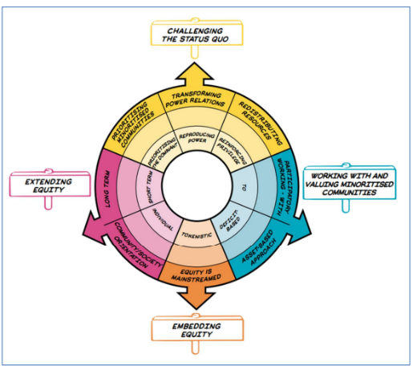

**Figure 8.2:** Equity Compass for Higher Education (adapted from YESTEM).

|  |
| --- |
| **Psychology of Democracy**  **Education: Case Study** |
| * The ‘Psychology of Democracy’ unit explores how citizens of democracies think and feel about their society, its institutions and how feelings shape societal dynamics. Understanding inequality is at the heart of the unit; citizens feel less represented if they feel they have less value and inequalities are often the root causes of populism, division and polarisation. * Discussions explore intersectional inequality with students encouraged to consider who might feel marginalised and how this impacts political engagement- aiding the students to develop empathetic and informed perspectives that can help reduce inequalities and strengthen civil society. |

* 1. **New Pioneering University Retreat to Support Student Mental Health**
  2. The University Retreat, a community front room mental health centre, specifically for students, was opened in March 2023 at the Talbot Campus. It is a safe and welcoming space for any student struggling with mental health and potentially approaching crisis point. In the first six months, the Retreat had an estimated 740 visits.
  3. The Retreat is a collaboration between BU, Arts University Bournemouth (AUB), AECC University College, Dorset HealthCare University NHS Foundation Trust, Dorset Mental Health Forum and BCHA (Bournemouth Churches Housing Association) and provides support to students from all three Bournemouth Universities.

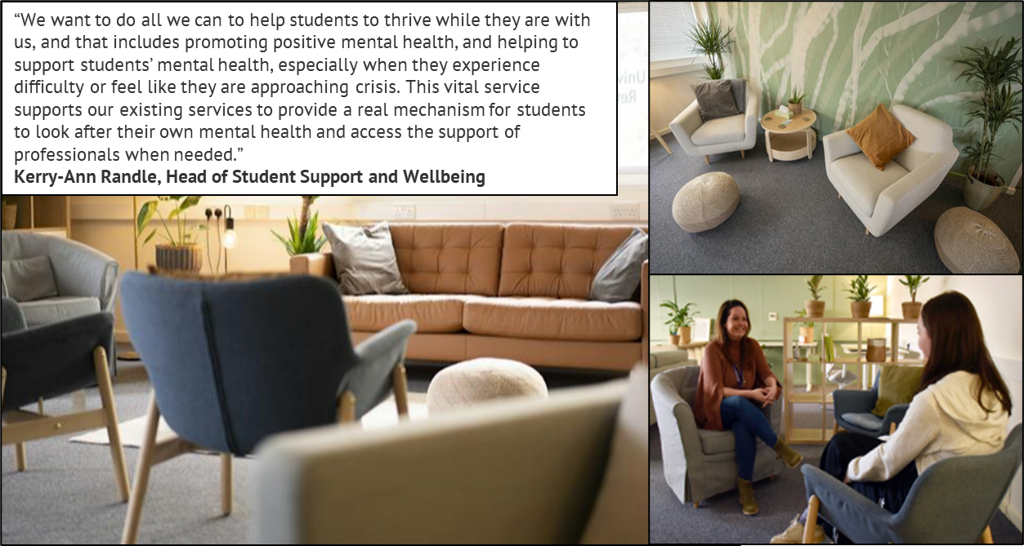

**Figure 8.3:** Images from the University Retreat.

# **A****ppendices**

**Appendix.1:** [Gender Pay Gap Reporting 2022](https://www.bournemouth.ac.uk/sites/default/files/asset/document/Gender%20Pay%20External%20Result%20Communication%202022%20FINAL.pdf)

**Appendix.2:** Equal Pay Review 2022

**Appendix.4:** [Access Participation Plan (2020/21- 2024/25)](https://www.bournemouth.ac.uk/about/governance/transparency/access-transparency#:~:text=Our%20Access%20and%20Participation%20Plan,participation%20plan%20(pdf%20162kb).)

**Appendix.5: Diversity Data**

* 1. **Overall Demographic Data for Staff and Students by Gender, Ethnicity, Sexual Orientation and Disability**

|  |  |  |  |  |  |  |
| --- | --- | --- | --- | --- | --- | --- |
| **Demographic** | **Breakdown** | **Staff Population** | | | **Student Population** | |
| **BU 2022/23** | **Vs.**  **BU 2019/20** | **Vs.**  **Benchmark** | **Student Population**  **2022/23** | **Vs. staff population** |
| **Gender** | Men | **43%** | 45% **(-2%)** | HE*: 37% | 44% | **+1%** |
| Women | **57%** | 55% **(+2%)** | HE*: 63% | 56% | **-1%** |
| **Ethnicity** | Asian | **7%** | 5% **(+2%)** | Black, Asian and Minority Ethnic:  HE*: 12%  BCP**: 18% | 11% | **+4%** |
| Black | **3%** | 2% **(+1%)** | 10% | **+7%** |
| Mixed | **3%** | 1% **(+2%)** | 5% | **+2%** |
| White | **83%** | 84% **(-1%)** | 69% | **-14%** |
| Other | **1%** | 5% **(-4%)** | 4% | **+3%** |
| **Sexual Orientation** | LGB | **5%** | 3.6% **(+1.6%)** | BCP**: 3.9%  HE*: N/A | 11% | **+6%** |
| **Disability** | Declared Disabled | **7%** | 6.1% **(+0.7%)** | BCP**: 18%  HE*: N/A (7%) | 17% | **+10%** |

*HE: [Higher Education Staff Statistics: UK, 2020/21 | HESA](https://www.hesa.ac.uk/news/01-02-2022/sb261-higher-education-staff-statistics)

**BCP: Census data for area profile for Bournemouth, Christchurch and Poole: [Ethnic group, national identity, language and religion | BCP (bcpcouncil.gov.uk)](https://www.bcpcouncil.gov.uk/about-the-council/ethnic-group-etc)

**1.2 BU staff by age demographic 2022/23**

|  |  |  |  |
| --- | --- | --- | --- |
|  | 2019/20 | 2021/22 | 2022/23 |
| Age | 60% aged between 41-60 | 59% aged between 41-60 | 57% aged between 41-60 |

**1.3 BU Student Age Demographic**

|  |  |  |  |
| --- | --- | --- | --- |
|  | Undergraduate | Postgraduate Taught | Postgraduate Research |
| Age | 81% 20 years and under | 71% 25 years and over | 60% 30 years and over |

**1.4 BU Student Gender Identity**

|  |  |  |  |
| --- | --- | --- | --- |
|  | 2020/21 | 2021/22 | 2022/23 |
| Trans and Non-binary | 0.6% | 0.7% | 0.9% |

**1.4 BU Staff by Gender, Ethnicity and Grade 2022/23**

|  |  |  |  |  |
| --- | --- | --- | --- | --- |
| Population | BU Overall | | | |
| **Total** | **Grades 1-4** | **Grades 5-8** | **Grades 9+** |
| BAME* Women | **109** | 28 | 58 | 23 |
| BAME* Men | **90** | 5 | 62 | 23 |
| White Women | **807** | 259 | 405 | 143 |
| White Men | **547** | 98 | 294 | 155 |
| Total Population | **1641** | 403 | 868 | 369 |

|  |  |  |  |  |  |  |
| --- | --- | --- | --- | --- | --- | --- |
| Population | Professional and Support Staff | | |  | Academic Staff | |
| **Grades 1-4** | **Grades 5-8** | **Grades 9+** | **Grades 5-8** | **Grades 9+** |
| BAME* Women | 28 | 19 | ** | 39 | 19 |
| BAME* Men | 5 | 17 | ** | 45 | 22 |
| White Women | 259 | 264 | 36 | 141 | 107 |
| White Men | 98 | 173 | 24 | 121 | 131 |
| Total Population | 403 | 487 | 69 | 381 | 301 |

*A Note on Ethnic Terminology: Whilst there continues to be debate about appropriate terminology in the context of minority ethnicities in the UK, for the purposes of this data reporting we have used the recognised term Black, Asian and Minority Ethnic (BAME). We fully recognise that the language to define different ethnic backgrounds is sensitive and not yet fully representative, therefore we continue to discuss and review the appropriateness and inclusivity of the language, as reflected in our Race Equality Charter action plan.

**Data responses less than five are not included to maintain anonymity.

**Equality, Diversity and Inclusion**

**PRIORiTIES: 2024- 2026**

* **Overview……………………………………………..**Page. 22
* **Strategic Importance……………………………..**Page. 23
* **Embedding EDI: Priority Focus Areas……….**Pages.24-30
* **Measuring Success………………………………..**Page. 31
* **Roles and Responsibilities……………………..**Page. 32
* **Appendix…………………………………………….**Page. 33

**Equality, Diversity and Inclusion Overview**

|  |  |
| --- | --- |
| **Our Vision** | |
| **Be You: Different Together.**  At BU, we work hard to develop and sustain a diverse and inclusive university community. Inclusivity is a core value that underpins the BU2025 strategic plan and beyond, and our vision is that this is a community and culture built on respect, compassion and curiosity, where our staff and students: | |
| * Feel welcomed for who they are and feel that they belong. * Feel valued, included and supported to reach their true potential. * Value and embrace diversity and play their part in advancing equality, diversity, and inclusion. |  |

|  |
| --- |
| **Legislative Context** |
| We work hard to meet our public sector equality duties under the Equality Act 2010 to:   * Have due regard to the need to:   + Eliminate unlawful discrimination, harassment and victimisation and other conduct prohibited under the Act.   + Advance equality of opportunity between people who share a protected characteristic and those who do not.   + Foster good relations between people who share a protected characteristic and those who do not. * Publish gender pay gap data by 31 March every year. * Publish one or more equality objectives at least every 4 years.   We want to go further than legal compliance and embrace institutional cultural change as we further embed our BU values. |

**Equality, Diversity and Inclusion Strategic Importance**

**Equality, Diversity and Inclusion (EDI) is beneficial for all.**

BU2025 articulates our vision to make a difference to the world and contribute to the enrichment of society. Our people are at the heart of what we do, and we know from the ever-growing research that diverse and inclusive institutions and teams perform better, have greater social impact and experience better wellbeing and satisfaction.

|  |  |  |  |  |
| --- | --- | --- | --- | --- |
|  |  |  |  |  |
| **BU Story** | **BU 2025 Strategic Plan** | **BU Values** | **UN Sustainable Development Goals** | **Widening Access & Participation** |
| **We challenge marginalisation, misinformation and under-representation.** | **We embed a culture of high performance**. | **Inclusivity**  Excellence  Creativity  Responsibility | **Achieve gender equality and reduce inequality** | **Reduce gaps in access, participation, continuation and award between students.** |
| ***We do this by listening to those who are often excluded from decision-making and helping them to be heard.***  A diverse and inclusive research community is needed to deliver innovative and rigorous research where diversity of people and ideas can thrive to enable new discoveries and solve global issues. | ***We do this by attracting and retaining diverse talent and having an inclusive environment that enables achievement for all.***  Every individual is different, and our differences mean more breadth and depth of ideas and experience. For example, organisations in the top quartile for ethnic diversity have a +39% likelihood of financially outperforming their peers.[[4]](#_‘Why_Inclusive_Leaders) | ***We do this by valuing and respecting diversity and acting to ensure that we are inclusive.***  Research consistently shows that people who work and study in an inclusive place deliver better quality outputs and have a better sense of wellbeing. | ***We do this through world-leading research, addressing our gender pay gap and advancing equality of opportunity.***  Advancing gender equality is critical to all areas of a healthy society, from reducing poverty and closing the pension gap to promoting the health, education, protection and wellbeing of girls and boys. | ***We do this by improving equality of opportunity for students from disadvantaged backgrounds to access, succeed in, and progress from higher education.***  Awarding gaps have potentially long-lasting and life-altering effects on students’ careers, lifetime earnings and it may also make these students less likely to continue in academia and so limiting the future talent pipeline. |

**Equality, Diversity and Inclusion Embedding EDI**

Universities are facing various pressures; simultaneously building inclusive and transparent cultures, transforming to meet the changing needs and demands of students and staff and addressing societal challenges, while seeking improved financial performance. Taking a systematic purpose-led approach to EDI better equips us to navigate these external challenges and positively impact holistic outcomes.

Our ambition is that EDI is truly embedded in our research, education, practice and is consciously considered in our decision making. We are proud of the progress we have made and recognise that embedding EDI requires continued and sustained cultural change in every function of the University. This is a sizable challenge, and our objectives provide a roadmap. However, the priority actions we have identified are not strictly linear and this is a not a tick box of actions. We will continuously listen and build our understanding and insight, particularly through our equality charter self-assessments, and evaluate and measure progress to learn and scale momentum.

|  |
| --- |
| **Belonging takes all of us.**  Individual staff and students, managers and senior leaders all play an important role in driving meaningful progress. By working together we can address inequality, create a truly diverse and inclusive community and enrich society. |

**Priority Focus Areas: Our Equality Objectives**

Our equality objectives have been informed by qualitative and quantitative data, gathered through (for instance) equality charter self-assessments and data monitoring of key processes.

We will:

1. Improve traction through changed governance and MI (management information) and focus on structural inclusion.
2. Equip and empower everyone to advance equity and inclusion, with a specific focus on strengthening inclusive leadership.
3. Expand opportunities and elevate under-represented talent.
4. Deliver progress through our Equality Charters and action plan promises.
5. Foster belonging and work life balance.
6. Foster an Inclusive Student Experience.

**Priority One Improve traction through changed governance and MI and focus on structural inclusion.**

**We embed EDI into our ways of working. We utilise data insight to inform actions and continuously review our approach to key people processes and policies to ensure that they are equitable and inclusive, fostering a sense of fairness and equality.**

|  |  |  |  |  |
| --- | --- | --- | --- | --- |
| **EDI Embedded into BU 2035** | **EDI Embedded in Business Activity & Local Priorities** | **EDI Data: Dashboard Insight & Reports** | **EDI KPIs** | **EDI Policies** |

**We will:**

* **Continue to embed EDI into our BU strategy,** ensuring a systematic purpose-led approach.
* **Embed our refreshed EDI governance to engage the wider community.** This includes supporting senior leaders communicate the EDI vision in their area and establish Faculty/Department EDI objectives with the support of new Inclusivity Leads, to build ownership and local impact.
* **Develop an EDI data dashboard** to make EDI data easily accessible to key stakeholders to ensure action is informed by insight.
* **Identify our key EDI performance indicators and make it easier for students and staff to see how we are progressing against key indicators that measure EDI progress.** The KPIs (key performance indicators) will supplement the suite of measurement we already have in place, such as addressing our gender pay gap, equal pay reporting and action plans, the Access and Participation Plan targets and our wide range of equality charter SMART action plans.
* **Build on our engagement mechanisms to listen to our BU community** to evaluate the extent to which everyone feels included and identify both strengths and opportunities for change. This includes utilising feedback from staff and student surveys, engaging with our networks and delivering focus groups. We will encourage staff with lived experience to use their voice in a range of ways to ensure decision making, policy and resources are best positioned and that the staff and student ‘voice’ is appropriately heard.
* **Regularly review and update our EDI policies** to ensure that they reflect changes to legislation and best practice, as well as our commitment to creating an inclusive environment.
* **Continually examine our structures, processes and practices** to ensure that they are inclusive, accessible and equitable for everyone. This includes updating our building design standards; implementing the actions resulting from Research Excellence Framework (REF) 2021 equality analysis and completing an inclusive language audit to inform updated BU brand guidelines.
* **Monitor and report pay gaps for staff and take targeted, strategic action** in response to equal pay reviews.

**Priority Two Equip and empower everyone to advance equity and inclusion, with a specific focus on strengthening inclusive leadership.**

**We support staff and students to take personal responsibility and accountability for their behaviour, actions and decision making to have a positive cultural impact and foster an inclusive environment with a strong sense of trust and psychological safety, enabling a high-performance culture.**

|  |  |  |  |  |
| --- | --- | --- | --- | --- |
| **Inclusive Leadership Development** | **EDI Training & Learning Resources** | **Enhanced Equality Impact Assessments** | **Inclusive Comms & Engagement Campaign** | **Report & Support Campaign** |

**We will:**

* **Strengthen inclusive leadership and accountability among managers,** to equip and empower our leaders to ‘Lead Inclusion’ and ‘Lead Inclusively’. This includes establishing new senior leader EDI champions, fully integrating EDI into leadership development, panel training and bespoke inclusive leadership programmes.
* **Develop, and build on existing, EDI training and learning resources for all staff to increase personal insight and awareness to drive action.** This includes bespoke EDI training (e.g. neurodiversity inclusion in response to increasing demand), updating our mandatory online EDI module and new learning resources available on our EDI SharePoint site.
* **Revise and strengthen the way EDI is considered in our decision-making processes by enhancing our approach to Equality Impact Assessments (EIAs)** with increased visibility, leadership and accountability. This includes developing a single portal for completion of EIAs; embedding meaningful tools and resources; and updating business case template to enhance inclusive equity-based decision making.
* **Increase and improve our communications about EDI and promote the new Inclusivity calendar.** We will work collaboratively to create a series of opportunities for the wider BU community to understand and shape the EDI agenda, including seeking to engage those who may be ambivalent about the value of EDI. This includes updating the internal and external EDI webpages and delivering a diverse series of webinars, events and podcasts to showcase cultural change activities, celebrate diverse stories, and raise awareness of key EDI issues.
* **Strengthen awareness and confidence in ‘Report & Support’ and BU’s zero-tolerance policy to all forms of harassment and hate crime.** This includes delivering anti-harassment and ‘call me in’ training and the Respect communication campaign to increase awareness, skills and confidence to challenge unacceptable behaviours.
* **Expand and deliver a Reverse Mentoring programme** to increase genuine awareness of different lived experiences and build cross-institutional relationships.

**Priority Three Expand opportunities and elevate under-represented talent.**

**We offer a range of career development, mentoring and training opportunities to support everyone to tap into their potential and thrive. In parallel, we take positive action to advance inclusivity amongst our staff and achieve better equity of opportunity to increase diverse representation at every level.**

|  |  |  |  |
| --- | --- | --- | --- |
| **Diversity Talent Programme** | **Pay, Promotion & Progression: Workshops & Live Bias Review** | **Embed EDI into Recruitment: Training, E-Recruit & Careers Site** | **Advance Progression of Part-Time Staff** |

**We will:**

* + **Continue to deliver and provide opportunities for tailored talent programmes** for specific groups to accelerate individuals’ ability to navigate challenges and achieve success, as defined by the individual. This includes on-going Aurora cohorts and exploring ‘WHEN 100 Women Black Professors Now’. The representation of women from a minority ethnic background falls relative to White women, White men and men from a minority ethnic background as seniority rises and there are no Black women in Grade 10+ roles.
  + **Continuously review our pay, progression and promotion processes** to ensure that they are equitable, mitigate bias and ensure fairness. This includes delivering panel training, exploring piloting live bias reviews, reviewing our special considerations process and delivering targeted ‘pay, promotion and progression’ workshops. At BU, there is a positive increase in applications from eligible women, academics from a minority ethnic background and staff who have declared a disability, however, further progress is required to address gaps in application and success rates.
  + **Further embed EDI into our recruitment processes** to advance inclusivity and mitigate bias in our decision-making. This includes enhancing the mandatory recruitment training to further embed bias awareness and behavioural change with practical tips; updating our external careers site to increase attraction of diverse candidates; and ensuring EDI is consciously considered in the build of the new e-recruit system.
  + **Explore barriers to progression for part-time staff** and implement insight-informed actions. At BU, 80% of part-time workers are women, and 77% of part-time staff work at Grades 1-5 in Professional Services. Part-time staff are paid less and the gap is growing (84% pay gap) and are less likely to progress (10% of eligible part-time staff applied for promotion v. 30% of full-time staff).

**Priority Four Deliver progress through our Equality Charters and action plan promises.**

**We work collaboratively across the BU community to implement our equality charter actions and maximise synergies to better align resources and increase the impact of actions.**

**Figure Priority 4:** Equality Charters, Action Plans and Schemes: Athena Swan (bronze), Race Equality Charter (bronze), Disability Confident Employer, The Concordat, University Mental Health Charter.

**We will:**

* **Continue, through our Inclusivity Action sub-committee and consolidated plan,** to bring together the multitude of actions across the equality charters- grouping the actions by themes and clarifying ownership. This will make it easier to understand how the work of the charters is inter-connected to help better align resources, increase visibility, create opportunities for collaboration and embed work into ‘business as usual’.
* **Continue to implement the actions we have committed to in the institutional, departmental and school-level Athena Swan charters** to advance gender equality and inclusion. This includes renewing our institutional Athena Swan commitment in 2024.
* **Implement and evaluate the impact of actions we have committed to in the institutional Race Equality Charter** to improve the representation, experience, progression and success of minority ethnic staff and students within higher education and renew our commitment in 2026.
* **Implement the actions we have committed to in the Research Concordat** to create a more positive, diverse, inclusive and open research culture.
* **Implement the actions we have committed to in the Disability Confident Charter and explore moving to Disability Confident Leader Status.**
* **Submit our self-assessment against the Mental Health Charter** and further embed a whole university holistic approach.

**Priority Five Foster belonging and support work life balance.**

**We work to create an environment with a strong sense of belonging and help our people thrive sustainably in key moments where life meets work.**

|  |  |  |  |
| --- | --- | --- | --- |
| **Bolstered Staff Diversity Networks** | **Enhanced Parental Support** | **Implement Health, Safety & Wellbeing Strategy** | **Personal Wellness Plans** |

**We will:**

* + **Bolster our Staff Diversity Networks** to ensure strong dynamic networks and grass roots engagement. This includes establishing and supporting staff network co-chairs and ensuring that their efforts are recognised. Our staff networks will deliver a regular calendar of engagement events for our BU community to enhance a sense of belonging.
  + **Enhance parental support** to ensure success strategies are in place for our working parents and address 20% leaver rates of maternity returners within one year. This includes exploring enhancing our parental leave entitlement and implementing increased wrap-around support e.g. manager toolkits.
  + **Implement the revised BU Health, Safety and Wellbeing Plan**. This includes enhancing caring support and developing a BU personal wellness plan (PWP). The PWP will provide a mechanism for regular conversations that consider the health and wellbeing of individual staff members, including those with a disability or long-term condition.

**Priority Six Foster an inclusive student experience.**

**We proactively work to foster student inclusion and wellbeing and ensure that all students feel that they belong on an equal basis and are empowered to succeed.**

|  |  |  |  |
| --- | --- | --- | --- |
| **Student Experience Strategies** | **New Access & Participation Plan** | **Inclusive Curriculum Project** | **Mental Health Charter** |

**This is realised through the delivery of the student experience strategies, including:**

* + **Access and Participation Plan (APP):** New APP, aligned to the ‘Theory of Change’ model, to be submitted in 2023/24. We will work with stakeholders across BU to identify priorities for action and intervention strategies that will improve equality of opportunity and support access, participation and success by students from under-represented groups.
  + **Inclusive Curriculum and Assessment project and resources:** Including inclusive education toolkit and workshops and Inclusive Evaluation Project to further deliver an inclusive education experience for all students.
  + **Mental Health Charter Submission and Action plan (2024/25)** to promote the mental health and wellbeing of all our students.

**Equality, Diversity and Inclusion Measuring Success.**

**We will use quantitative and qualitative data to evaluate and monitor progress. A high-level overview will be monitored by the EDI Committee and progress is reported to the University Leadership Team (ULT) and Finance Resource Committee (FRC) through our annual EDI report.**

**Success measures include:**

* + **Delivery of Equality Charter Action Plans:** Each equality charter action plan is designed to be SMART and provide outcome and success measures that we will monitor.
  + **Progress against EDI KPIs:** We will identify key EDI performance indicators to supplement the suite of measurements we already have in place, including our gender pay gap target.
  + **Progress against the EDI Maturity Model:** We will utilise the EDI maturity model to facilitate informed discussions to explore our EDI journey. (Appendix 1)

**Equality, Diversity and Inclusion Roles and Responsibilities.**

**Our progress will be led by, implemented and monitored by the people and groups set out below.**

|  |  |
| --- | --- |
| **Role** | **Responsibility** |
| **University Executive Team** | * Ensure legal compliance and governance. * Ensure that adequate resources are allocated to the work and that the priorities are aligned with wider BU work. * Model and champion the EDI principles within the areas and functions that they are responsible for. |
| **BU Executive EDI Lead** | * Set the strategic direction for BU. |
| **BU EDI Committee** | * Provide strategic oversight and ensure that the EDI vision, mission and ambition set out in the EDI strategic plan is delivered and remains current. * Provide assurance to ULT, on the delivery of the strategic plan for EDI and BU’s compliance with its statutory duties. |

**The groups below will help influence the strategic direction:**

|  |  |
| --- | --- |
| **Role** | **Responsibility** |
| **Faculty and Departmental Leadership Teams (inc. Inclusivity Lead)** | * To make the institutional strategic vision relevant to their local area and to feed up to the EDI committee good practice and significant issues. |
| **Senior ULT EDI Champions** | * Mentor and partner with the equality charter leads and staff network co-chairs to build and deliver the strategic agenda plan. |
| **Institutional Equality Charter Self-Assessment Teams** | * Work as a multi-disciplinary team to gather the necessary data and evidence and analyse the findings to help write a high-quality self-assessment submission and ensure the implementation of the associated actions. |
| **Staff Networks** | * Grassroots peer support that brings people with shared experiences and identities together to support each other and BU. |
| **EDI Team** | * Provide expertise, knowledge, practical advice and critical challenge to help embed EDI across BU. |

**APPENDIX**

**1.Equality, Diversity and Inclusion Maturity Model**

Source: The Deloitte diversity and inclusion model (adapted)

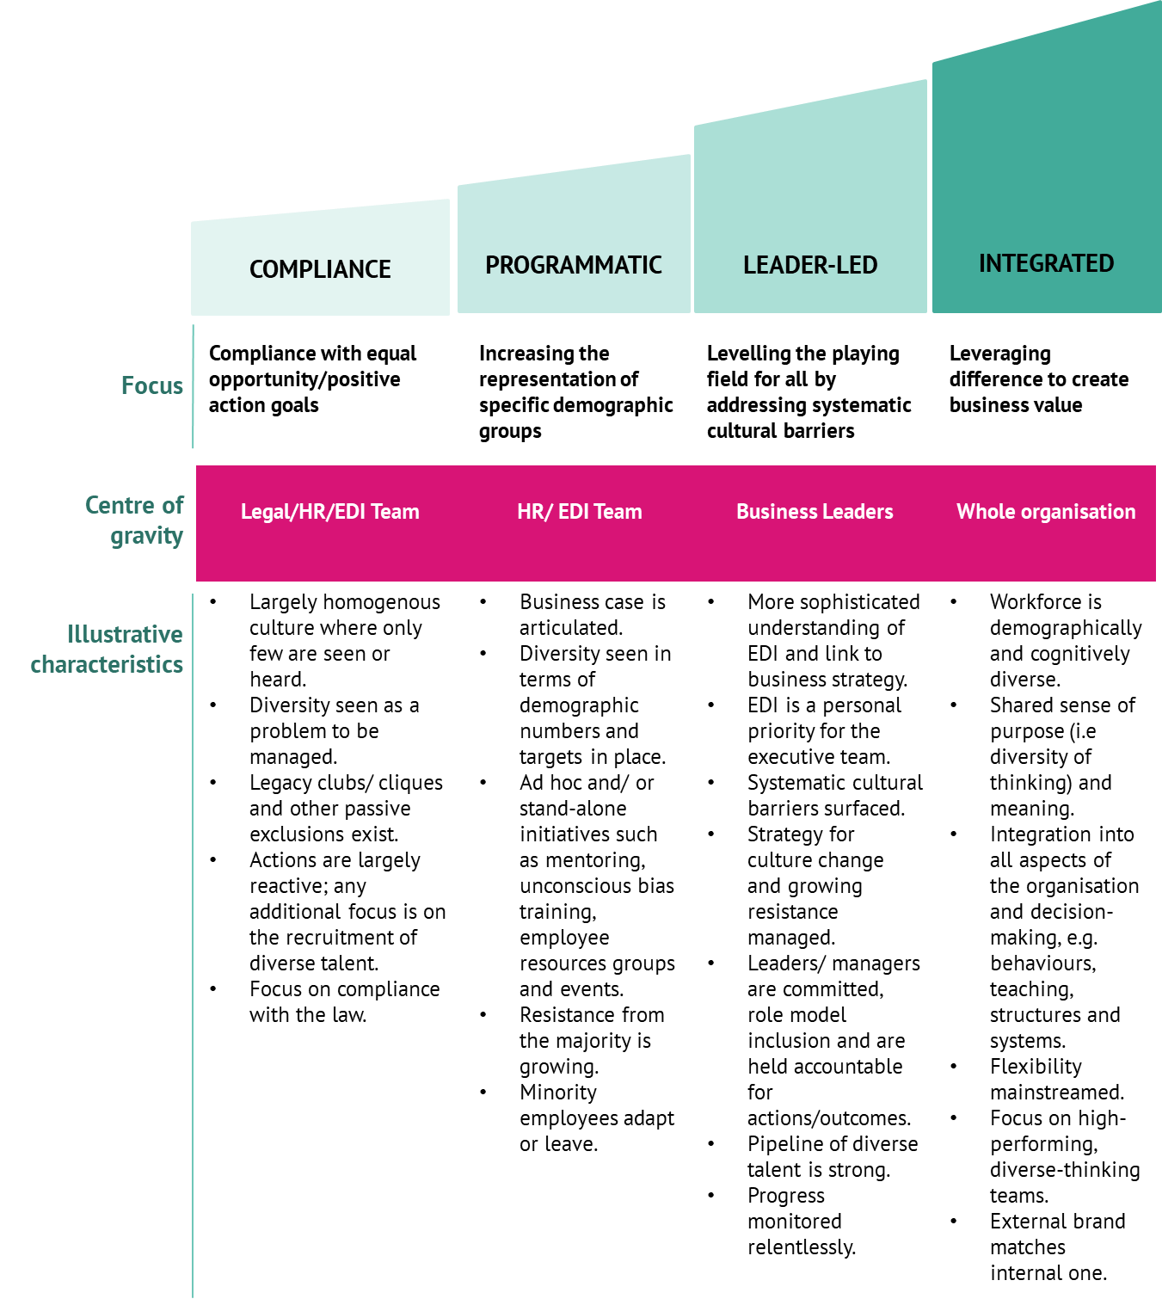

1. # ‘Why Inclusive Leaders Are Good for Organizations, and How to Become One’ Juliet Bourke and Andrea Titus

  
2. This data has been taken from the ‘2022/23 Academic Pay, Promotion and Progression Paper’. Following publication there have been several appeals and grievances resulting from the 2023 academic pay progression and promotion process. Additional analysis evidences that the majority of findings are broadly in line with the numbers of applications and do not suggest that any one group was more likely to appeal or to be unsuccessful than any other. The exception appears to be White British women, who only had a success rate of 33% following an appeal/grievance.
3. As above- this data has been taken from the ‘2022/23 Academic Pay, Promotion and Progression Paper’.
4. [Diversity matters even more: The case for holistic impact](https://www.mckinsey.com/featured-insights/diversity-and-inclusion/diversity-matters-even-more-the-case-for-holistic-impact?stcr=BC456D42DFEE4602977468E2EF8C0ACE&cid=other-eml-nsl-mip-mck&hlkid=9794e290a28947daaae428966397fd14&hctky=14979524&hdpid=3e12b036-51df-4868-b86d-d3d0a31a311c) | McKinsey