Covid-19 Exceptional Circumstances Form [TAUGHT AWARDS]

The University is operating a self-certification process for any student whose studies have been impacted by symptoms of Covid-19, caring for someone with Covid-19, technical issues or wider impact of the disease.

You can use this form to request extensions to coursework deadlines/postponement of scheduled online examinations or Exceptional Circumstances Board consideration in situations where your performance has been impacted by Covid-19.

You should use the standard extension request or Exceptional Circumstances Board consideration request forms for any matter that is not related to Covid-19.
The diagram below provides guidance as to which form you should use:

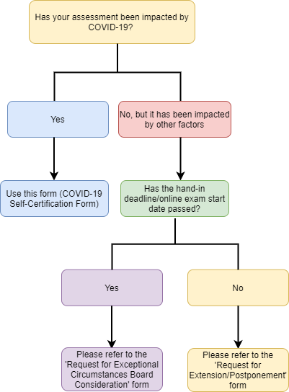

1. Student Details
Surname (Family Name) |  | First name
Student ID number |  | Level (4/5/P/6/7)
Telephone number
Programme
Programme Leader
Faculty

2. Details of Assessments Impacted
Please indicate the names of specific units, the specific assessment types, and the assessment dates that have been
affected by COVID-19:
Unit Name | Assessment type
 | Coursework/ Assignment title |  | Online Examination
 | Submission date: |  | Online Exam date:
 | Submission date: |  | Online Exam date:
 | Submission date: |  | Online Exam date:
Type(s) of Exceptional Circumstance:  If you are requesting more  than one type of  Exceptional Circumstance,  please indicate which  assessments these are  requested for. | Extension or online exam postponement  Please request this option if you are reporting circumstances prior to the hand-in date or online examination date.
Board Consideration
Please request this option if you are reporting circumstances that have impacted your performance in assessment that you have already submitted or if you did not complete your assessment before the deadline/online examination date.

3. Details of circumstances
Tick as appropriate
I have COVID-19 symptoms |  | Date of first illness:
I am caring for someone with suspected Covid-19 |  | Provide details and date of first illness:
I cannot access technology or resources required to complete my assessment, due to self-isolation or services affected by Covid-19 |  | Provide details and dates affected:
Other impact of Covid-19 |  | Provide details and dates affected:

4. Declaration
By submitting this form you are declaring:
- the above information is accurate to the best of your knowledge; and
- that you understand the information provided in support of your request will be treated in confidence unless
disclosure is necessary to progress the claim.
Student Name
Date

5. PROGRAMME TEAM TO COMPLETE
Extension/Postponement Granted? | Yes / No
If Yes; New Submission Date:
Board Consideration Granted? | Yes / No
Date student was informed of outcome (only for extension and exam postponements)
This is normally within 7 calendar days of receipt of this form but only where extensions/ postponements are requested before the deadline(s).
Name
Job Title
Date

