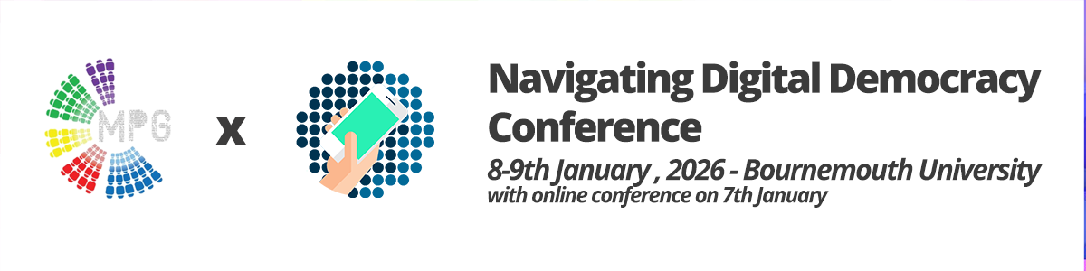
7th January 2026.
All panels will be held on Zoom. Links to follow.
All times are in GMT (UK time).
9.00 – 10.15am
Panel: Platforms for Politics
- Fajar Martha (University of Indonesia)
Influencer Activism, Elite Critique, and Democratic Backsliding in Indonesia: Lesson from the Failed ‘17+8’ Movement
- Paweł Surowiec-Capell, Chris Miles (University of Sharjah; AFG College with the University of Aberdeen)
Public Engagement with Foreign Policy Using ‘Diplotainment’: Evaluations of a Hybrid Genre
- André Almo, Ana Jovanovic-Harrington, Maíra Amaral (Technological University Dublin; Dublin City University)
Games as Political Communication in Authoritarian Regimes
- Weidong Jin (University of Leeds)
Platformizing Neoliberal Femininity with Chinese Characteristics: A Case of RedNote
10.15 – 10.30am
Break
10.30 – 12.00pm
Panel: The Changing Face of Journalism
- Huyen Trang Nguyen (Bournemouth University)
Challenging narratives: How development journalism shapes LGBT+ representation in Vietnamese media
- Antal Wozniak (University of Liverpool)
Media narratives of ‘the West’ in non-Western mainstream news: A case study of Brazilian, Indian, and South African reporting about the Russo-Ukrainian war
- Susana Sampaio-Dias (University of Portsmouth)
“You’re so sensitive! I’ll make sure one of your KPIs is to develop a thicker skin!” Early-Career Women Journalists' expectations and experiences of breaking through the sector
- Alev Aslan, Nilüfer Timisi, Yeliz Dede Özdemir (İstanbul University)
The Representation of ‘Women Experts’ as Speaking Political Subjects in Political Debate Programs on TV
- Leonardo Desideri (Independent Researcher; PhD in Communication, Universidad de Navarra)
The Rise of Almost-News: How Proto-Event Coverage on Digital Platforms Turns Signals, Hints, and Moves into Breaking News
12.00 – 12.30pm
Lunch
12.30 – 2.00pm
Panel: Technology, Governance, & Democracy
- Lambprini Papadopoulou, Theodora A. Maniou (National and Kapodistrian University of Athens; University of Cyprus)
Democracy Under Surveillance: Digital threats and challenges to press freedom
- Anuradha Sajjanhar (University of East Anglia)
Epistemic Infrastructures of AI in Governance: Expertise, Legitimacy, and Democratic Accountability
- Mohamed Ben Moussa (University of Sharjah)
Technocratic Governance and Poverty in Morocco: Critical Discourse Analysis of Morocco’s Social Index
- Natacha Ferreira Moreira (Universidade Federal Fluminense – UFF, Brazil)
Digital Colonialism: Discourses on the Construction of Data Centers in the Global South and the New Stage of Capitalism
- Nael Jebril (Doha Institute for Graduate Studies)
Artificial Intelligence and Public Discourse in Arabic-Language Mainstream Media
2.00 – 3.00pm
Keynote. Jonathan Corpus Ong
Exposing Disinformation Economies: Lessons from Asia and the Global South
3.00 – 3.15pm
Break
3.15 – 4.45pm
Panel: Discussing Politics in the Digital Age
- Vera Gailis (Independent Artist, Curator, Researcher)
Reclaiming Visual Agency: Counter-Dataset Practices for Democratic Participation in the Age of AI
- Sameera Alotaibi (Bournemouth University)
Constructing Saudi Arabia's Image through Mega Events: Institutional and Western Media Discourse
- Marta Cantijoch, Andrés Bernstein (University of Manchester; University of the Balearic Islands)
Hostility on Social Media and the Moralization of Politics in the United Kingdom
- Thiago Costa (State University of Rio de Janeiro)
Nostalgic Platforms: How Tradwife Content Shapes Anti-Democratic Imaginaries
- Andrea Villalobos-Moreno (Universitat Pompeu Fabra)
Presidential Standup: Critical Analysis of Daily Press Conferences in the Mexican Presidency
4.45pm
Conference close

