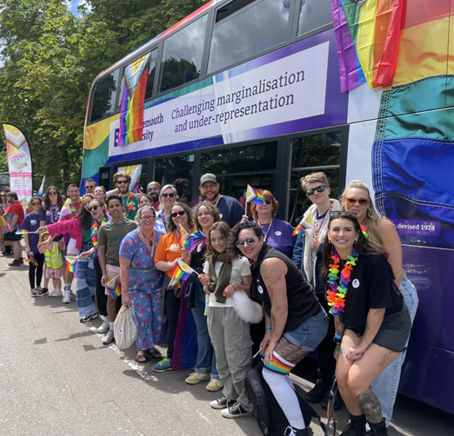

Equality, Diversity and Inclusion Annual Report 2024

Equality, Diversity and Inclusion Annual Report 2024
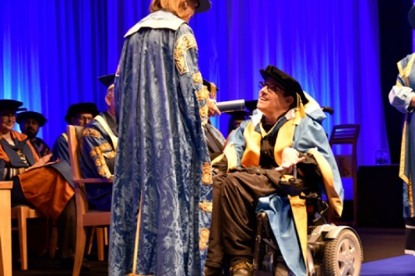






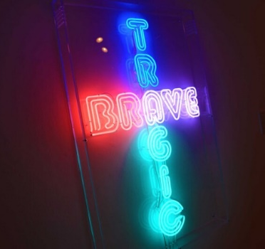




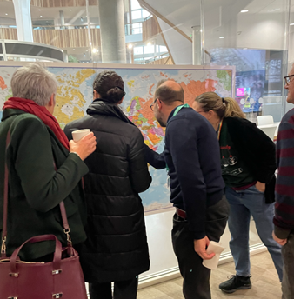
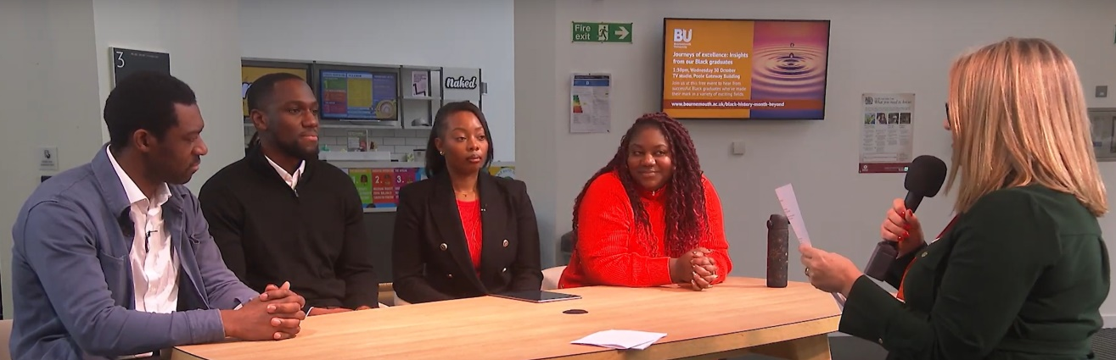

Equality Diversity and Inclusion Annual Report 2024

Foreword

This annual Equality, Diversity, and Inclusion (EDI) report celebrates the achievements and progress made in embedding equality, diversity, and inclusion (EDI) at BU throughout 2024.

2024 has been a year of transition. We welcomed our new Vice-Chancellor, Alison Honour, and as we approach the conclusion of our BU2025 strategy, we are actively working with colleagues to shape our next strategic plan—BU2035. As we refine our 10-year roadmap, EDI remains a golden thread running through our institutional vision.

One year into our EDI Strategic Plan, our vision remains clear: to further cultivate a community built on respect, compassion, and curiosity—where everyone feels they belong and can thrive.

We are proud of our increasingly inclusive and diverse community and the progress we have made this year, including; launching new staff networks; enhancing to our recruitment processes to further foster inclusivity and equitable opportunities; signing up to Hidden Disabilities sunflower scheme; hosting a vibrant ongoing calendar of EDI events, attracting over 400 attendees; introducing new bitesize EDI learning to engage a wider audience; continued investment in diverse leadership talent pipelines through the Inclusive Coaching pilot and Aurora cohort; supporting over 3000 student visits to our Mental Health Retreat; and strengthening inclusive leadership by embedding psychological safety into our Change Leadership workshops, attended by 90% of managers.

We are also proud to share our new ambitious Access and Participation Plan, aligned with the Theory of Change model, which aims to enhance equality of opportunity across the student journey- particularly in closing awarding gaps.

Our commitment to meaningful change has been recognised externally. BU was ranked No. 2 in the inaugural Higher Education Honordex report, which evaluated EDI practices across UK universities. Our gender pay gap reduced again by 1.5% , reaching its lowest level since reporting began in 2017. Additionally, our efforts to consolidate previously siloed action plans into a single Inclusivity Action Plan—providing clearer oversight of institution-wide progress—were commended in an independent EDI audit by PwC.

We all have an important role to play in driving meaningful progress and this report recognises an enormous amount of work from across our community. We are grateful to everyone who has contributed to fostering an inclusive culture. While we celebrate these achievements, we know there is more to be done, and we remain committed to listening, evaluating progress, and taking action.

Karen Parker
HR Director and EDI Sponsor

Context

This report provides an overview of the work undertaken during 2024 to promote equality, diversity and inclusion (EDI) across BU. Our EDI Annual Report plays an important role by helping us to continuously measure and share our progress going forward.

This report also outlines how BU is meeting the requirements of the Equality Act 2010 and Public Sector Equality Duties. In accordance with our obligations under these we are required to:
- Have due regard to the need to:
  - Eliminate unlawful discrimination, harassment and victimisation and other conduct prohibited under the Act.
  - Advance equality of opportunity between people who share a protected characteristic and those who do not.
  - Foster good relations between people who share a protected characteristic and those who do not.
- Publish gender pay gap data by 31 March every year.
- Publish one or more equality objectives at least every 4 years.

It should be noted that this annual report does not seek to capture the totality of EDI work across BU during this year; this is already covered in detail through ongoing initiatives and our various equality charter submissions and action plan deliverables. These include our Access and Participation Plan, Gender Pay Gap Report and Action Plan and our Race Equality Charter submission. The report summarises major milestones and key achievements during the year, highlighting areas of strength, as well as those that still require focus and attention.

Key Progress Against our Equality Objectives

In accordance with the EDI 2024-2026 Strategic Plan, this section provides an assessment of our strategic progress against the six established Equality Objectives and goals.

1. Improve traction through changed governance and MI (management information) and focus on structural inclusion

  - We are further embedding EDI into our ways of working, leveraging data insights to inform actions, and continuously reviewing key people processes and policies to ensure that they are equitable and inclusive, fostering a sense of fairness and equality.
  - Our diversity data campaign has improved staff disclosure rates, which will enable us to make more informed, evidence-based decisions. The growth and revitalisation of our staff networks are also providing richer qualitative insights. We have also made significant progress in inclusive recruitment, enhancing the candidate experience and strengthening fairness in hiring practices.
  - However, there is more to do—particularly in continuing to strengthen governance. While good practice exists at a local level, there are opportunities to enhance collaboration and align efforts. The Athena Swan Department Leads Forum demonstrates the value of a community of practice, where peers can seek advice and share best practices. Expanding this approach and reinforcing local accountability—including embedding an EIA mindset and establishing senior sponsors—will be key to driving long-term, sustainable change.
  - Governance, Data Insights and Strategic Alignment
  - Embedding EDI within the new BU strategy, BU2035: Embedding EDI in BU2035 is not just about EDI-related goals, it’s about ensuring all staff voices and diverse perspectives shape our future direction. To achieve this, we have prioritised meaningful staff engagement throughout the process. In addition to extensive engagement sessions and workshops across BU (circa.500 attendees), we held a bespoke session with staff network co-chairs (13 attendees) and a dedicated meeting between staff network chairs and the Vice-Chancellor.
  - Aligning EDI with Sustainability Goals: Recognising the intersection between EDI and sustainability, particularly UN Sustainable Development Goals SDG 5 (Gender Equality) and SDG 10 (Reduced Inequalities), we are seeking opportunities to align activities. We recognise the profound responsibility, opportunities and capabilities we have for actioning the UN Sustainable Development Goals through our research, education, practice and collaboration with the wider community. As part of this commitment, all programmes must align with at least one SDG. Our analysis shows strong alignment with SDG 5 and SDG 10 across faculties (see below) and initiatives like the Women’s Academic Network event on Intersectional Feminist Research Methodologies provide actionable insights to strengthen inclusive research practices:
      - 76% in the Faculty of Media & Communication
      - 87% in the BU Business School
      - 94% in the Faculty of Science & Technology
      - 96% in the Faculty of Health & Social Sciences
  - Using Staff Survey Data to Drive Change: Our EDI-focused analysis of staff survey data revealed key insights:
    - 57% of staff feel a strong sense of belonging at BU.
    - Key drivers of engagement include, ‘our values reflect the way we work’ and that ‘BU is committed to making a positive difference’. ‘Key drivers’ are items which have the strongest relationship with engagement, and so are important to our community.
    - 53% feel safe speaking up and challenging how things are done. Whilst this is 5% higher compared to the sector this is an area we want to address, particularly as there is a gender difference in this response.
    - Immediate action: We integrated Psychological Safety into the ‘Leading Change and Innovation’ Strive Higher Change Leadership Programme (90% managers attended).

  - Inclusive Recruitment Enhancements
  - The launch of a new recruitment system, e-ploy, provided an opportunity to foster a more inclusive candidate experience, and help reduce the risk of bias in the hiring process. In 2025, we will analyse our recruitment data to understand the impact of these efforts. Key improvements include:
    - New Adtuner tool- to help craft inclusive and engaging job descriptions by highlighting content for optimisation- including biased language, and providing alternatives to consider to attract a wider diverse talent pool.
    - Improved job advert templates to highlight flexible working and inclusive benefits (e.g. on-site nursey) to make roles more attractive and accessible to a wider diverse talent pool.
    - Implemented anonymised applications for professional services roles, removing identifiable data to help mitigate bias in shortlisting.
    - Updated equality monitoring form to include a ‘self-describe’ option, encouraging higher data disclosure to enable us to better analyse recruitment trends, evaluate the impact of inclusion efforts and inform targeted action at an institutional and local level.
    - Clearer signposting for reasonable adjustments at all recruitment stages, ensuring accessibility.
    - Refreshed manager recruitment training, with EDI embedded throughout, including practical tools to mitigate cognitive biases, ensure fairness, and enhance decision-making.
  - Strengthening Equality Impact Assessments (EIAs)
  - Refreshed EIA guidance and template: The new Equality Impact Assessment (EIA) guidance alongside a simplified template is designed to be user-friendly while reinforcing the importance of engaging diverse groups and using data to drive evidence-based decision-making. The guidance includes an annotated EIA template to support newer users.
  - Expanded scope: We have incorporated caring responsibilities and socio-economic background as key considerations, alongside the existing protected characteristics outlined in the Equality Act 2010.
  - Next Steps: In 2025, we will enhance this further by developing new online training. We also intend to embed the recommendations from the Advance HE cross-university EIA review, once available and if feasible, which we hope will help further enhance our guidance and support.

2. Equip and empower everyone to advance equity and inclusion, with a specific focus on strengthening inclusive leadership

- We are investing in our leadership teams to strengthen the inclusive leadership capabilities of our managers. Understanding and being adept at inclusive leadership will enable our leaders to thrive in an increasingly complex and diverse change environment. Research shows that what leaders say and do accounts for up to 70% of an individual’s sense of inclusion, and teams with inclusive leaders report higher performance, better decision-making, greater collaboration, and reduced absenteeism.

  - Our new EDI Hub and Inclusivity Calendar enable us to better promote the wealth of resources, events, and learning opportunities available across BU. Through community and regional events, as well as research-led initiatives, we are embedding EDI into our foundations—not just supporting change, but actively leading it.
  - While we’ve made significant progress, we know there is always more to do to engage the widest possible audience. Achieving real, lasting change requires both individual and collective action. By working together, we can create a more inclusive and equitable environment for everyone.
  - Building Inclusive Leadership Capability and Inspiring Leaders to Adopt this Mindset
  - Embedding EDI in Organisational Development Processes: We are actively supporting managers in making fairer, more inclusive decisions by addressing cognitive biases. These biases can influence everyday choices, potentially resulting in unintended disparities. For example, research shows that demographic factors, rather than job performance, often determine the quality of performance feedback received, with underrepresented groups typically receiving lower - quality feedback compared to their peers. This has significant implications for engagement, career progression, earning potential, and overall equity within institutions. To help address this:
    - We have worked with our Deans to consciously integrate EDI considerations into Talent and Succession Planning discussions and have provided guidance on using 'bias interrupters.'
    - We also offer practical support for equitable and inclusive feedback in appraisals, signposting resources such as Textio’s ‘Performance Feedback’ course. These tools help managers deliver feedback to everyone that is specific, actionable and growth oriented.

  - Psychological Safety Embedded in Strive Higher Change Leadership Programme; 90% managers attended. This was designed to better equip leaders to embody these behaviours and consequently cultivate psychological safety across their teams and BU. As considerable prior research shows, psychological safety is a precursor to adaptive, innovative performance—which is needed particularly in today’s rapidly changing environment. We are exploring further interventions in 2025.
  - New EDI specific Line Manager Essentials Module currently in development for launch in 2025: This module aims to further support inclusive leadership by equipping managers with the skills, knowledge, and confidence to lead inclusively and enable their teams to thrive. It will cover key topics such as equitable decision-making, reasonable adjustments and fostering an inclusive team culture.
Spotlight: Academic Reverse Mentoring in the Faculty of Media and Communication
Team: Dr Gloria Khamkar & Professor Fiona Cownie

Academic reverse mentoring is an innovative approach that fosters two-way learning, fostering a more dynamic, responsive, and effective learning environment for all participants. Unlike traditional mentoring approaches, where senior faculty mentor junior faculty or students, academic reverse mentoring flips the dynamic, with junior individuals mentoring senior counterparts.
In January to May 2024, we piloted the Academic Reverse Mentoring scheme in the Department of Communication and Journalism, pairing postgraduate researchers (PGRs) with academics, The primary goal was to cultivate a sense of community among academics and post-graduate researchers based on shared cultural understanding.
Objectives of the scheme:
- To build connections between individual PGRs and academics
- To build PGRs’ confidence and cultural knowledge relating to studying in the UK
- To enhance academics’ cultural competencies
- To increase communication between PGRs and academics beyond the supervisory relationship

Following the success of the pilot, we are now expanding Phase 2 (January–May 2025) to the entire Faculty of Media and Communication, with 16 volunteers from all four departments.
  - Ongoing Calendar of Events, Communications and Learning Opportunities to Engage the Widest Audience
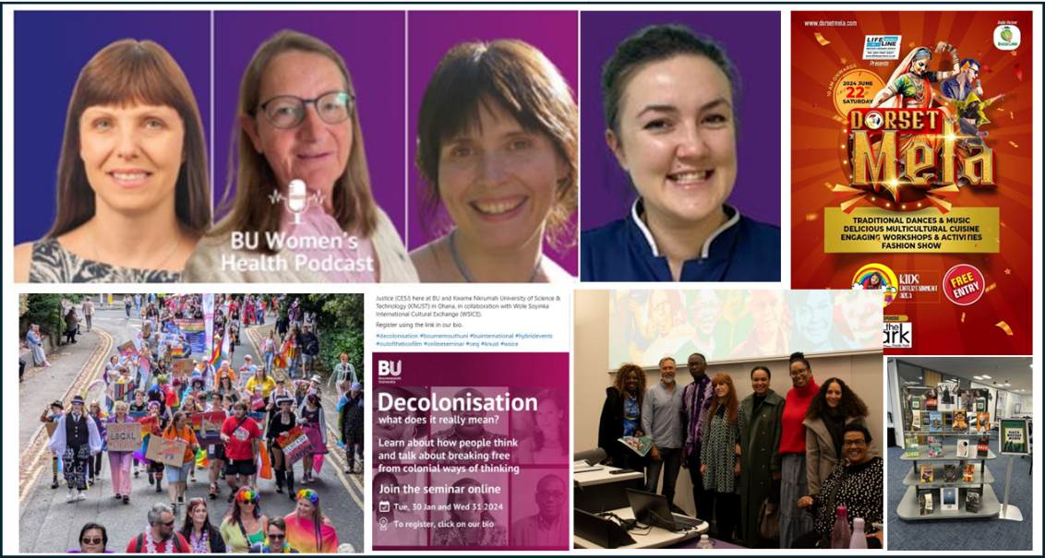
  - Increasing and improving our communications about EDI, working collaboratively to create a series of opportunities for staff to engage in critical EDI topics. These initiatives, which weave together storytelling, listening, and shared experiences, reinforce the message that BU believes in and prioritises the power of diversity and inclusion. The Inclusivity Calendar includes events such as the Celebrating Neurodiversity Conference, Black History Month Alumni Panel, Race Equality Research Conference, BourneFree parade, Human Libraries, and podcasts etc. With circa. 900+ podcast listens and 400+ event attendees, these initiatives amplify diverse voices and build allyship, helping to foster a more inclusive culture and increase a sense of belonging for all staff.
  - New internal EDI Hub and Updated EDI webpages: Making information and resources more accessible and improving visibility of support networks, events and learning opportunities—encouraging engagement and collaboration across BU.
  - New suite of online EDI bitesize learning modules launched. These short, engaging modules are crucial in today’s fast-paced, digital-first world, offering accessible, flexible learning that can be easily integrated into busy schedules. By providing knowledge in digestible formats, we aim to make it easier for staff to stay engaged and continuously develop their understanding. 114 staff completed the modules since launching in September.
  - Bespoke Training: Responding to staff requests we have delivered Bias Awareness workshops for various departments.
  - Neurodiversity Focus: We are developing neurodiversity inclusion training for all staff, complementing our new bitesize Neurodiversity module. Embracing neurodiversity in the workplace is essential for creating an inclusive and productive environment where all cognitive styles are valued. Neurodiversity inclusion-focused events throughout the year also create spaces for discussion and raise awareness around neurodiversity.


Spotlight: Culture Corner With Elaine and Gloria! Podcast

Hosted by Elaine Warriner (Internal Communications Manager) and Dr. Gloria Khamkar (Principal Academic in Journalism), this podcast series explores a wide range of cultural topics, including the impact of globalisation on cultural exchange, the significance of language and literature, sports and culture, and the diverse musical, culinary, and festive traditions around the world.

The podcast also delves into history and heritage, offering insights into pivotal events and figures from various cultures. The series also showcases outstanding work at BU, including the Inclusive Curriculum Evaluation Project, reinforcing the university’s commitment to diversity and inclusion.

Listen Here!

  - Strengthening Community Engagement & External Impact
  - Working Together with our Local Community: We continue to work with local partners, and host regular on-campus meetings with local charities and community support organisations. These meetings provide a collaborative space in which attendees are invited to share their expertise and resources, so that we can make a positive difference together.
  - Regional & National Impact: Our motto, Discere Mutari Est – to learn is to change, reflects our commitment to transforming society and we are committed to driving positive impact through research, events, and community collaborations to drive meaningful dialogue and community impact. Examples from 2024 include:
Regional Event: Celebrating Neurodiversity – Strategies, Successes, and Stories | Idea Ignition Retreat Day: How can researchers fight against racism towards East and Southeast Asian communities
In association with ALDinHE and co-sponsored by BU’s Faculty of Media & Communication, this event explored lived experiences and strategies for empowering neurodivergent students. | This retreat brought together British Academy ECRN members and others whose work focusses on racial and social justice, migration, cultural politics, identity, and activism, among others.
Seed Talks ‘Understanding Autism in Women and Girls’ | BU-UHD Leadership Conference fostered dialogue on race equality in healthcare leadership.
Dr.Rachel Moseley highlighted the lesser-known and seen female experience of autism, helping attendees feel more informed and connected. | Co-delivered with University Hospitals Dorset NHS Foundation Trust with several partners from across the region, the event included a discussion on racial inequalities in health and the ways in which inclusive leaders can challenge these inequalities.

3. Expand opportunities and elevate under-represented talent

- We offer a range of career development, mentoring and training opportunities to support everyone to tap into their potential and thrive.

  - In parallel, we continue to deliver targeted positive action initiatives designed to help individuals thrive and achieve their career goals. Through leadership talent development, including Aurora, executive coaching, and mentoring, we are actively investing in building a diverse leadership pipeline that reflects our university community. We also remain committed to supporting the Women’s Academic Network, which champions the success and wellbeing of women in academia.
  - These initiatives aim to level the playing field to achieve better equity of opportunity and increase diverse representation at every level. The initiatives are implemented alongside broader efforts to drive systemic change in advancing inclusion.
  - Inclusive Futures Coaching Pilot: Investing in our Equality Charter and Staff Network Chairs
  - As part of a cross-university initiative led by Strive Higher, we participated in the Inclusive Futures Coaching Programme, a pilot designed to nurture diverse leadership talent development and create a supportive, inclusive workplace. Participants were paired with highly skilled external executive coaches, providing dedicated space and time to reflect on and explore opportunities, clarify goals and take meaningful steps to achieve professional goals.
  - At BU, this opportunity was offered to our Equality Charter chairs and staff network co-chairs, with seven participants engaging in six coaching sessions over a six-month period. We will evaluate its impact in 2025 to inform future plans.
  - Aurora: Empowering Women in Leadership
  - This year, 17 women from BU are participating in the Aurora Programme, Advance HE’s flagship leadership development initiative designed to empower women to realise their leadership potential and take proactive steps toward career growth. Each participant is paired with a BU mentor for additional support and guidance.
  - Notably, 50% of the 2023/24 cohort have since achieved career advancements, including promotions or securing permanent roles at BU.
  - ‘Aurora Plus’ Initiative: Expanding Access to Leadership Development
  - To respond to the high demand, but limited spaces, for the Aurora Programme, we launched ‘Aurora Plus’, extending support to an additional 35 applicants. This initiative includes mentorship opportunities and two bespoke events:
    - ‘My Career Story’ with Alison Honour – A networking event with our Vice-Chancellor, which participants described as ‘inspiring’ and ‘motivating.’
    - ‘Women's Sat Nav to Success’ – A half-day session led by Diana Parkes, author of ‘Understand, Dare, Thrive’, helping equip participants with the insights and skills needed to navigate their careers effectively, helping them recognise and optimise their potential at BU. Participants reported feeling motivated, inspired, excited and clearer about their next steps.
  - Across Aurora and Aurora Plus, we have recruited circa. 30 internal mentors from our leadership teams. This not only supports mentees but also helps mentors enhance their inclusive leadership skills, gain diverse perspectives, and strengthen their ability to develop talent within BU. Mentors were also invited to engage in Aurora Plus sessions, reinforcing their critical role in facilitating opportunities and encouragement.
  - Looking ahead, we are evaluating the impact of these programmes to explore how future offerings might maximise learning and enhance engagement. Additionally, we are exploring participation in the 100 Black Women Professors NOW initiative—WHEN’s 12-month accelerator programme addressing the significant underrepresentation of Black women in UK academia and drive meaningful change in the sector.
.
  - Women’s Academic Network: Championing the Success of Women at BU
  - The Women's Academic Network (WAN) is dedicated to fostering an inclusive and supportive environment that champions the success and wellbeing of women in academia. This year, WAN:
    - Hosted several speaker events.
    - Delivered five successful writing retreats, offering members dedicated time to focus on research and academic writing.
    - Sponsored a range of gender-related research activities across the university.

  - The writing retreats are one of the most valued aspects of the network, providing members with dedicated space to focus on academic pursuits. Members have highlighted how these retreats offer much-needed time for research and writing, leading to tangible outcomes such as academic bids, journal article publications, and professional collaborations.


4. Deliver progress through Equality Charters and action plan promises
- x
  - We are committed to several 'Equality Charters' related to equality and inclusion. These frameworks and commitments help us to identify and address organisational and cultural barriers standing in the way of equality for specific groups of staff and students.

  - The implementation of action plans and the need to maintain our various charter award levels is significant for the University’s reputation as an inclusive educator and employer, but also comes with substantial resource demands. Key stakeholders from the BU staff and student community support the planning and delivery of the self-assessments and action plans.
  - The recent PwC audit commended our progress in consolidating previously siloed EDI action plans into a single Inclusivity Action Plan- providing clearer visibility of institution-wide progress. The audit also highlighted strong alignment and collaborative working practices between EDI and wellbeing.
  - However, the audit also identified areas for improvement, particularly around ensuring all actions are consistently specific and actionable. Addressing this has been a key focus, with further enhancements expected in 2025 through the introduction of a new project management tool to enhance reporting visibility and ease of tracking progress. Completing and submitting our Athena Swan self-assessment and action plan is also a priority in 2025.
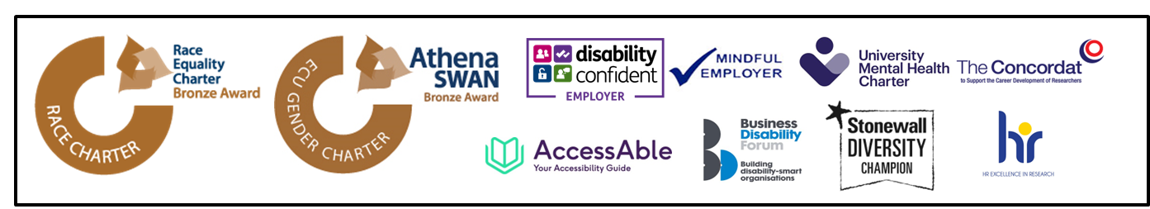
Figure 4.1: BU commitments: Race Equality Charter (bronze), Athena Swan (bronze), Disability Confident Employer, Mindful Employer, University Mental Health Charter, The Concordat, AccessAble, Business Disability Forum member, Stonewall Diversity Champion and HR Excellent in Research.

  - Consolidating and Delivering EDI Action Plans
  - To help better align and consolidate the breadth of EDI activities taking place across BU, and help better understand our progress, we have merged the multiple Equality action plans into a single, comprehensive Inclusivity Action Plan. Actions are aligned to key themes, helping embed a collaborative and intersectional approach. Working closely with action owners we have also further clarified ownership and timelines to enhance accountability and visibility of progress. Oversight is provided by the EDI Action Sub-Committee, chaired by a Dean, reporting to the EDI Committee.
  - This work was further supported by a PwC audit of our EDI strategy and governance. As a dynamic plan, we continuously seek improvements, including enhancing impact evaluation and development of a more user-friendly and automated project management and reporting system.
  - Equality Charter Commitments
  - Mental Health- Whole University approach to Mental Health: BU remains committed to the University Mental Health Charter (UMHC) and Mindful Employer status. The University Mental Health Charter has four domains, Live, Learn, Support and Work. Each domain is being led by a Senior Manager from BU. Over the past year we have been collating evidence for our self-assessment in preparation for our application for a full UMHC audit and assessment.
  - Athena Swan- Championing Gender Equality: Institutional renewal in progress; six departments now hold local awards. We have re-established and re-energised our Institutional Athena Swan Self-Assessment Team, including recruiting a new Chair and Deputy Chair. We have also conducted focus groups and data insight investigations, alongside a facilitated workshop to evaluate current progress and inform new action priorities, in readiness for our submission in July 2025. Six departments now also hold a local Athena Swan award; Computing & Informatics; Media Production; Archaeology and Anthropology; Design and Engineering; Life and Environmental Sciences; and Psychology.
  - Race Equality Charter- Advancing Race Equality and Inclusion: Inaugural submission awarded Bronze in 2023. Ongoing delivery of the Race Equality Charter action plan and membership refresh has been the focus in 2024.
  - Disability Inclusion Commitments: Disability Confident Employer, Business Disability Forum member, AccessAble member, and new signatory of the Hidden Disabilities Sunflower. In 2024, we signed up to the Hidden Disabilities Sunflower Scheme, offering staff and students free access to Sunflower lanyards and raising awareness of hidden disabilities. Our AccessAble membership provides detailed accessibility information about BU campuses, buildings, and facilities.
  - HR Excellence in Research Award and UK Concordat to Support the development of Researchers: 10 years of Commitment. We successfully retained the HR Excellence in Research Award for a tenth year in 2023, and the 2023-2026 action plan is in delivery to further foster a positive research culture.

5. Foster belonging and support work-life balance

  - We work to create an environment where everyone feels a sense of belonging and can thrive—especially at key moments where life meets work. We’re continually building a workplace that values flexibility, connection and inclusion. In 2024 we strengthened our staff networks, enhanced wellbeing initiatives, increased paid carers leave, expanded online manager guidance, piloted a 50% staff discount on kids’ clubs and improved support for international colleagues.
  - As we navigate change, we remain focused on ensuring staff voices shape our evolving support. A key priority is further equipping managers with the skills and confidence to have person-centred conversations—balancing staff wellbeing with business needs while consistently supporting reasonable adjustments.
  - Growing our Staff Networks: Grassroots Engagement & Fostering Belonging:
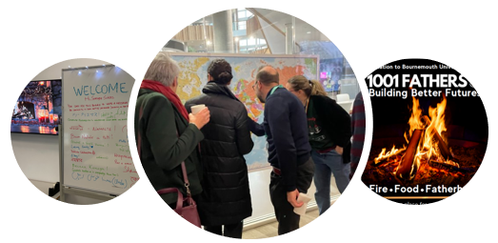

  - In 2024, we’ve expanded and re-energised our staff networks, creating spaces where over members connect, support each other, and influence change. Each network is led by its members, setting their own objectives while collaborating with the University to influence organisational strategies and policies aimed at enhancing the overall staff experience. These networks play a crucial role in fostering a sense of belonging and community—providing spaces where colleagues can feel supported, connected, and empowered throughout their careers.
  - Our current staff networks include:
    - Race Equality Network
    - Carers Network
    - Women’s Academic Network
    - Menopause Network
    - Pride Network
    - Parents Network
    - Accessibility, Disability & Neurodiversity Network
  - Additionally, Unison has launched a new Women’s Network, open to all BU staff. Beyond our formal networks, we also offer a variety of community groups—more informal, social spaces based on shared interests.
Spotlight: Men’s Wellness Group Pilot

In 2024, we piloted a series of men’s wellness initiatives. These activities were designed to create a supportive environment where men can connect, share experiences, and engage in meaningful practices that enhance their overall wellbeing. Reflecting on engagement and feedback, we will continue key initiatives into 2025:
- Fire Fellas- an informal, agenda-free gathering where men connect over meaningful conversations by a crackling fire in the woods, led by Layne Hamerston.
- 1001 Fathers- a space for new and expectant fathers to learn, recharge, and share experiences.
- 5‐a‐side football tournament- a SportBU-led event raising awareness for Men’s Health Week, now set to become an annual fixture.

- Enhancing the Experience of our International Staff
  - As an international staff community, we thrive on the rich diversity of experiences and perspectives, and by working together across cultures, we unlock greater potential for innovation, collaboration, and growth—strengthening our university’s global impact.
  - In 2024, based on staff feedback, we introduced:
    - New International Coffee Mornings – Over 60 attendees joined our first event, building connections across the university.
    - Welcome Information for International Staff – A new webpage signposted through recruitment, offering practical guidance for a smoother relocation.
    - Staff Accommodation in the Student Village – Offering short-term housing to ease the transition, already receiving positive feedback.
    - Promotion of our Immigration Fee Assistance Scheme – Enabling visa fees to be covered via salary advance to reduce financial strain.
    - New Working Across Cultures EDI Module – A new bitesize online module, designed to build confidence in navigating cultural differences, avoid stereotypes, and foster effective collaboration in diverse teams.

  - Looking ahead, we plan to launch World Culture Workshops, an International Staff Induction Module, and integrate name pronunciation options into email signatures—small but impactful steps towards an inclusive workplace.
  - Growing Faith and Reflection Team
  - Faith plays a key role in identity and belonging. Our Faith & Reflection Centre is an open, inclusive space, offering confidential support, events, and moments of pause in a busy university environment.
  - The number of associate chaplains continues to grow and we recently welcomed an associate chaplain to represent the Quakers religion. There is now a more diverse representation of Faiths in the community who are working together as one team to create a truly interfaith environment.
  - The team celebrates religious festivals throughout the year, including Sukkot, Iftar gatherings during Ramadan, and Advent reflections, among others. The team also ran Understanding Grief and Loss workshops and supported the Faces of Faith exhibition—a student-led project documenting the diverse individuals who use the Faith & Reflection Centre. Through photography, the exhibition highlights the shared connections within this inclusive space.

  - On-going Delivery of BU’s Health, Safety and Wellbeing Strategic Plan
  - EDI and the Health, Safety, and Wellbeing Team (HSW) continue to collaborate to support staff wellbeing. Example wellbeing and inclusivity initiatives highlighted below:
  - Fertility Awareness and Support: New comprehensive guidance for staff and line managers, has been launched, with the introduction of online training opportunities to follow next year.
  - Support for Domestic Abuse Survivors: As members of the Employers’ Initiative on Domestic Abuse (EIDA), we remain committed to raising awareness of the devasting impact of domestic abuse, supporting affected staff, and encouraging proactive employer action. In addition to existing resources:
    - Promoted the Phoenix Programme for BU staff and the wider community. Led by academic colleagues in the Faculty of Health & Social Sciences, this educational support group provides referral opportunities and vital assistance for individuals who have experienced or are experiencing domestic abuse.
    - Research at BU, in partnership with Yellow Door and Stop Domestic Abuse, has shown that minority groups face additional barriers when seeking support. These findings have informed service improvements and highlight the urgent need for long-term, sustainable investment in specialist domestic abuse services.
  - Carers’ Leave Enhancement: Going beyond statutory entitlements, BU now offers up to one week of leave per year, with two fully paid days. This enhancement has been well received by members of the Carers Forum, many of whom have already benefited from the added flexibility.
  - ‘Managing Wellbeing’ Line Manager In Person Training: Equipping leaders to support staff wellbeing and implement reasonable adjustments effectively.
  - Menopause Awareness and Support: As part of our commitment to fostering an inclusive workplace and a supportive working environment, BU has signed the Menopause Workplace Pledge in partnership with Wellbeing of Women. This reflects our dedication to:
    - Listening to what our staff need
    - Encouraging open conversations across the organisation
    - Providing appropriate adjustments, policies, and support for staff experiencing menopause
    - Raising awareness internally and across our network
    - Making menopause information widely accessible to all staff.
Our Menopause Hub offers guidance for both staff and managers, including practical resources on working together to identify supportive measures, recognising that understanding an individual’s experience is key to implementing adjustments that enable them to thrive at work. Additionally, the Health, Safety, and Wellbeing team provides one-to-one support and guidance.
We also have an active and growing Menopause Network, which plays a crucial role in shaping our approach. In response to member feedback, we run a series of engagement sessions, this has included, Menopause and Midlife – What’s Autism Got to Do with It? and Navigating Change Together – Menopause and Its Impact on Family Relationships, in collaboration with Dorset Mind. Furthermore, we are supporting Dorset Mind’s Active Monitoring Pathways, including a menopause-specific pathway now implemented nationwide.

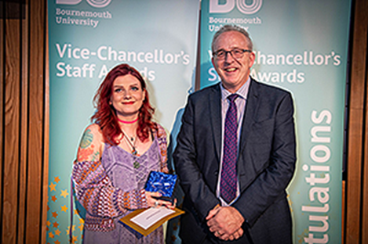
Heritage, Craft and Wellbeing: The Sanctuary Project
A standout grassroots initiative is The Sanctuary – Heritage, Craft & Wellbeing Hub, led by Megan Russell in Archaeology & Anthropology. Developed as part of Megan’s PhD research into the benefits of outdoor craft activities, these sessions offer staff, students, and the local community the opportunity to explore traditional crafting skills while benefiting from their positive impact on wellbeing.

Recognised with the Vice-Chancellor’s Inclusivity Award- a great example of research-led, real-world impact.

Women’s Health Symposium: Driving Change in Healthcare

The Women’s Health Symposium brought together academics, clinicians, researchers, and third-sector organisations to explore key priorities in women’s healthcare.

The event featured several members of the Womens Academic Network, including Dr Malika Felton on cold water swimming in pregnancy and Dr Sarah Hillier on LGBTQ+ parenting experiences, alongside Associate Professor Alyx Taylor, expanding local collaborations on perinatal mental health.

Presentations aligned with the Women’s Health Strategy for England, covering health inequalities, service access, education, and mental health.

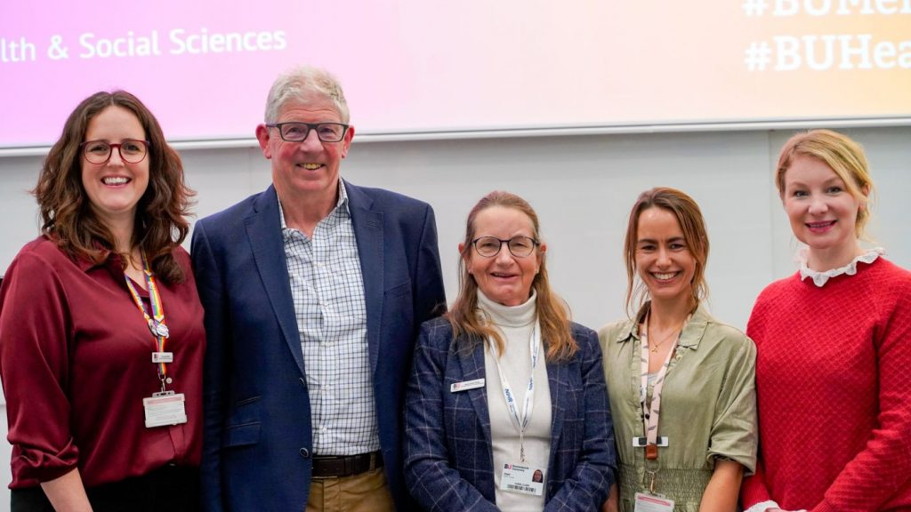

6.Foster an inclusive student experience

- At BU, ensuring an inclusive experience for all students is a key priority. We want every student to feel a sense of belonging, to thrive academically and personally, and to have equal opportunities to succeed.

  - Our work in this area spans multiple interconnected initiatives, each playing a vital role in shaping an equitable and supportive university environment.
  - Our commitment to high-quality, inclusive learning is reflected in our Silver rating in the Teaching Excellence Framework (TEF) 2023, which recognises our efforts to provide a well-rounded high quality student experience and address real-world challenges through our commitment to the UN Sustainable Development Goals. Additionally, the Inclusive Curriculum Evaluation (ICE) Project continues to drive progress and improve the inclusivity of the curriculum. Strengthening student voice mechanisms is also a key focus, with a new SharePoint hub providing a central space for consolidated information.
  - We are also committed to enhancing access and participation, and we are proud to launch our new Access and Participation Plan, which sets out how we intend to achieve long-term improvements in equality of opportunity. At the same time, student mental health and wellbeing remain central to our work. We are pleased to announce continued funding for our pioneering mental health retreat, which has already supported over 3,000 students since opening.
  - New Access and Participation Plan: Improving Equality of Opportunity
  - Through our Access and Participation Plan (APP), we aim to enhance equality of opportunity for underrepresented student groups, ensuring they can access, succeed in, and progress from university. Access and Participation plans apply only to Undergraduate, Home-fee region students and are a regulatory requirement monitored by the Office for Students (OfS).
  - In 2024, we continued delivering our 2020/21 to 2024/25 Access and Participation Plan (APP), making progress towards our targets while also developing a new APP for 2025/26 to 2028/29.
  - By analysing our data, we identify key areas where intervention is most needed to achieve our objectives. Our approach is based on clear objectives to reduce disparities, measurable targets to track progress, and evidence-based intervention strategies designed to address specific challenges. Alongside these priorities, we also monitor short-term trends that may indicate emerging risks to equality of opportunity, allowing us to respond proactively where necessary.
  - Delivering Progress Against our 2020/21 to 2024/25 Access and Participation Plan: Throughout 2024, we continued to deliver our commitments and made progress toward our targets. While some targets were met or exceeded, others highlight areas where further work is needed. The table below provides a summary of key outcomes:
Access and Participation Plan: Targets, Milestones and Progress
APP Targets and Written Commitments | 2023/24 Milestone | Baseline | Outcome
Access: To reduce the gap in participation in Higher Education for students from areas with low university participation (LPN)  Target is set on new entrants to BU using, POLAR4* as the metric) | 2.35  Ratio of new entrants from quintile 5 (highest participation): quintile 1 (lowest) | 2.89 | Target not met: 2.52. Further progress needed to improve entry rates of students from LPN.
Continuation: To reduce the gap in continuation in Higher Education for students from areas of low participation. (LPN POLAR 4*) | Quintile 5-1 gap: 0.4pp | 1.9 | Target not met:  –4.7pp gap.  Further support needed to improve retention.
Continuation: To reduce the gap in continuation in Higher Education between White and Black students. | 0.3pp Gap, or lower | 2.0 | Target exceeded:  -0.2pp gap  (Black students had a slightly higher continuation rate than White students).
Attainment: Reduce the degree awarding gap (proportion of students achieving a 1st or 2:1) between White students and Black, Asian and minority Ethnic (BAME**) students. | 7pp gap | 15.6% | Target not met:  17.5pp gap.  A significant gap remains, further action required to address inequalities in degree outcomes.
Attainment: Reduce the degree awarding gap between students with and without a declared disability. | 0.9pp gap | 6.2% | Target exceeded:  2.3pp gap.  Disabled students had a higher attainment rate than those without a declared disability.
Progression: Reduce the gap in progression into graduate-level employment or further study between White students and students and Black, Asian and minority Ethnic (BAME**) students***. | 1.6pp | 6.2% | Data not directly comparable.  3.5pp gap in latest Graduate Outcomes data (different dataset, so not directly comparable). Continued focus needed to improve graduate outcomes.
Table 6.1: Access and Participation Plan: Targets, Milestones and Progress.

Gap based targets are measured in percentage points (pp)
* POLAR4 has historically used as a proxy for socioeconomic disadvantage. It is being replaced by IMD (index of multiple deprivation) and Free School Meals (FSM)_ eligibility in our new APP
** This terminology, BAME, is historic and no longer used in our new APP
*** Based on Destination of Leavers from Higher Education (DLHE) data

  - Developing the New 2025/26 to 2028/29 Access and Participation Plan
  - In 2024, we developed a new Access and Participation Plan (APP) for the 2025-26 to 2028-29 period. As APP requirements have been strengthened, this new plan includes more detailed evidence, in-depth data analysis, and specific intervention commitments than previous versions. These interventions are underpinned by a theory of change approach, ensuring a structured and evidence-based response to addressing inequalities in access, success, and progression.
  - The new Access and Participation Plan was approved by the OfS in December 2024.
  - Our assessment of performance identified persistent gaps and ‘risk indications’ for underrepresented student groups at BU (see Figure 6.2):
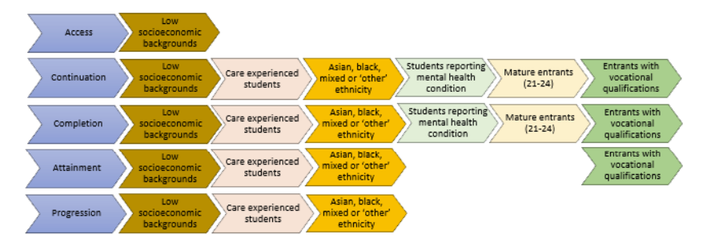
Figure 6.2: Risk Indicators at BU by lifecycle stage
  - Based on this analysis, we established five key objectives and nine measurable targets, which will be addressed through six intervention strategies designed to improve equality of opportunity across the student journey.

  - Inclusive Learning, Representation and Support
  - We are committed to fostering an inclusive learning environment where all students feel represented, supported, and empowered to succeed. Beyond curriculum design, we provide a range of initiatives that enhance inclusivity, promote student wellbeing, and create spaces for meaningful engagement:
  - Inclusive Curriculum Evaluation (ICE) Project: The ICE Project is a key initiative aimed at fostering inclusivity in curriculum design. In 2023-24, the project expanded its focus from unit-level to programme-level reviews. It recruited and trained 15 student reviewers, mainly from minority ethnic backgrounds, to assess inclusivity across seven programmes and one long cross-curricular unit. Key highlights include:
    - Collaboration between student reviewers and students on the course/ programme.
    - Positive response from programme and unit leaders, with the majority identifying actions to improve the inclusivity of their curriculum in the future.
    - Promotion of findings and learnings through FLIE, Race Equality Conference, BU podcasts, and academic networks, including the academic sustainability network.
    - Planned expansion in 2024-25 to incorporate broader aspects of diversity.

  - Student Voice: Student feedback is essential in shaping an inclusive learning experience. Ensuring that students are active partners in shaping their education enables the University to implement meaningful improvements, share best practices, and address challenges that may impact student success. Student representation is encouraged across all levels of the institution as a fundamental channel for hearing the Student Voice at the University. The Student:Staff Forum is one example of this, providing a collaborative space where programme teams and Student Reps work together to enhance the learning experience through engagement in quality enhancement and assurance. To further strengthen student engagement, new SharePoint pages have been developed to showcase the full range of opportunities, channels, and initiatives available for students to share their voices and see how their input leads to real change across the University.
  - Additional Learning Support: In 2023/24, we reviewed our Additional Learning Support Service to enhance the way we support students with complex needs. As a result, we introduced a new Complex Needs Panel for prospective students, ensuring earlier conversations about significant adjustments related to estates, timetabling, accommodation, and health and safety. By identifying and addressing these needs before students arrive, we are helping to remove barriers to learning, improve student confidence and independence, and create a smoother transition into university life. This proactive approach ensures that students with disabilities can fully engage with their studies and university experience from day one.
  - Targeted & Equitable Careers Support: We recognise that career progression into high-skilled employment is an integral part of the student experience, however graduate outcome data evidences that students from low socioeconomic backgrounds and minority ethnic groups are less likely to progress into high-skilled employment. Our goal is to ensure that all students have equitable access to career opportunities and the support they need to succeed. Activities included:
    - 2,136 individual career appointments.
    - 36+ specialist Career Workshops & Networking: Sessions included topics such as CV writing, interview skills and ‘meet the professionals’ events with sectors such as sport, legal, women in STEM, and specialist sessions for cohorts such as students with disabilities and international students.
    - upReach Partnership: in 2023/24, BU partnered with upReach, a social mobility charity, to support 22 Level 5 students from disadvantaged backgrounds. Participants received one-to-one job coaching and attended employability days, leading to five students securing internships with employers such as Mondelez, Autovista, and Peters & Peters.
    - BESSA (Bath Employment Support School for Autism) Event: A dedicated employability two-day event for autistic students or graduates. BESSA aims to help with the transition from university to a range of opportunities. All students reported increased confidence and clarity about their career aims.

  - Belonging, Community and Support: SUBU Liberation Officers and student-led networks play a key role in shaping an inclusive university culture and deliver a year-round calendar of events aligned with national awareness days. Additionally, in partnership with SUBU, BU provides free period products to address period poverty. Initiatives like Rainbow Office Hours (February 2024) offer safe, drop-in spaces for conversations with LGBTQ+ staff allies, while the Digital Lives of Young LGBTQ+ Workshop explores the intersection of digital experiences and LGBTQ+ identity. For neurodivergent students, the BU ASD & ADHD Student Wellbeing Group provides peer-led support, education sessions, and guest speaker events. These are a handful of the many initiatives that help foster an inclusive and supportive environment at BU.

  - Student Wellbeing and Mental Health
  - We are committed to taking meaningful action to support student mental health, recognising the growing need for support and the complex challenges many students face.
  - The Cibyl Mental Health Survey, which BU participated in for the first time in 2023/24, has provided valuable and, at times, sobering insights into the mental health experiences of our students. These findings highlight the significant mental health challenges students encounter and will play a crucial role in shaping our approach. We will use this data to review and enhance how we support student mental health, ensuring it forms a key part of our self-assessment for the University Mental Health Charter and our ongoing commitment to continuous improvement. Alongside this, we already have a range of targeted and proactive interventions in place, including:
    - University Mental Health Retreat – Open since 2023, the retreat has welcomed over 3,000 student visits. The retreat is a community front room mental health centre, specifically for any student struggling with mental health and potentially approaching crisis point. Funding has been secured from Dorset Healthcare Trust for another 12 months, with plans to make the retreat permanent. Future developments include facilitating recovery education sessions for students to develop coping mechanisms , clinical outreach drop-ins to improve access to specialist support, and the potential transformation of the upstairs space into a staff wellbeing retreat.
    - Dedicated Mental Health Advisors: A team of six qualified professionals, including a psychologist, counsellors, social workers, and a mental health nurse provides specialist support to over 350 students with declared diagnosed mental health conditions.

    - 24/7 Counselling Support: In addition to on-campus counselling, students also have access to the Student Assistance Programme which provides 24/7 counselling by telephone, live chat or where appropriate online. The service is available in 250+ languages, ensuring accessibility for international students.

    - Suicide Prevention Strategy: Developed in partnership with Arts University Bournemouth (AUB) and Health Sciences University (HSU), and with the support of the local Clinical Commissioning Group, this strategy has been in place since November 2021 and is reviewed annually. Updates are shared at the Universities Suicide Prevention Summit, which in 2024 was held on World Suicide Prevention Day (September 10th) and attended by over 120 staff. Now in its fourth year, the strategy continues to evolve to strengthen suicide prevention efforts across our university community.

Demographics, Data and Policy Updates

- Legislation Updates

  - In 2024, key changes in employment law strengthened workplace rights and protections. At BU, we seek to go beyond statutory requirements where possible, enhancing our policies and practices to support our people and foster an inclusive culture.
  - Recent developments include the Carers Leave Act, giving carers the right to one week’s unpaid leave—at BU, we offer two days fully paid. Parental leave enhancements allow paternity leave to be split into two blocks, and neonatal care leave changes are expected in 2025. We continue to provide six months' paid maternity leave and on-site nursery support. The Flexible Working Act now allows requests from day one of employment. To help our people balance work and personal life we support a wide range of flexible working options, including part-time, job-share, compressed hours, and hybrid working, and we will also offer 30 days’ annual leave for all staff (plus bank holidays and closure days) from April 2025.

  - Equality Act 2010 Amendments and Preventing Sexual Harassment
  - The Equality Act 2010 (Amendment) Regulations 2023 were implemented in January 2024 to preserve certain discrimination protections post-Brexit. These amendments ensure that existing equality provisions remain robust and enforceable.
  - The Worker Protection (Amendment of Equality Act 2010) Act strengthens employer obligations to prevent workplace sexual harassment. This builds on the framework we already have in place, which includes harassment policies, an online confidential reporting tool, and training. We have updated our Sexual Harassment and Sexual Misconduct policy, and the new legislation offers an opportunity to further strengthen our actions, especially in addressing third-party harassment.
  - Additionally, in 2025, there will be strengthened regulation coming into force from the Office for Students (OfS) to prevent harassment and sexual misconduct and protect students. The removal of the use of Non-Disclosure Agreements came in to force in August 2024, this is not practice BU has ever adopted so was already in place. The aspect of the new regulation which will have the biggest impact is that Universities must provide mandatory training for students on sexual harassment and misconduct, which comes in to force in August 2025. This will require a significant review of our current policy, practice and current resource to deliver. Continuing to support our students is at the heart of our approach and the STARS service offers a confidential drop-in at the Student Wellbeing office once a month, offering support to anyone in Dorset affected by sexual trauma, regardless of when or where it occurred.
  - The Higher Education (Freedom of Speech) Act 2023 ('the Act')
  - The Act was passed in May 2023 but is not yet in force. The new act strengthens and enhances free speech duties at universities. As a university we have a responsibility to balance our free speech duty, alongside our responsibilities to safeguard the dignity and respect of staff and students (as laid down in the Equality Act 2010). Academic freedom and freedom of speech are one of our core values, and championing the voices of marginalised and underrepresented groups is central to our strategic priorities. Our commitment to inclusion explicitly encourages the diversity of ideas and valuing different perspectives and therefore compliments our fundamental commitment to academic freedom.
  - Looking Ahead, Labour’s Employment Rights Bill (October 2024) is expected to introduce further reforms, enhancing worker protections and employment rights. We will continue to monitor and adapt our policies to stay ahead of these changes.
- Preventing and Tackling harassment

  - At BU, we are committed to providing a positive working environment for all and uphold a zero-tolerance policy for discriminatory behaviours, including bullying and harassment, and actively help managers and staff to identify and address microaggressions.
  - Online Report and Support Tool
  - Our online Report tool is one way our staff and students can report incidents of harassment or discrimination, one of the key features is that anonymised reporting is possible too. We continue to strengthen awareness of, and confidence in the tool.
  - In 2023/24 we launched a RESPECT communication campaign to increase awareness of the tool, our commitment to inclusivity, reinforce our zero-tolerance policy and develop a shared language for Respect at BU. The campaign reached over 2,000 views on news stories and nearly 3,000 accounts on social media. Our communications continue, now aligning with our wider communication strategy to support the introduction of external legislation and regulatory changes on preventing sexual harassment.
  - Reports
  - In 2023/24 we received one complaint reporting a possible hate crime which related to a disturbance in the prayer room. This was fully investigated with the support of the Islamic Faith advisor, student and staff community and the neighbourhood policing team and resulted in a review of cleaning arrangements and improved signposting on how to report and escalate concerns.
  - Student reports of sexual misconduct come via a number or routes including our online reporting form, a disclosure to any member of staff, a student complaint or increasingly from The Shores and/or STARS with the student permission. In 2023/24, there were 10 reported incidents from students.
  - In 2024, two incidents of sexual misconduct involving staff were reported via our online reporting tool, and in the 2023/24 period, seven formal Employee Relations cases related to EDI were investigated, six of which fell under our Sexual Harassment and Misconduct Policy.
  - We recognise that such cases are often underreported and continue to encourage reporting. The increase in reported cases may be influenced by our enhanced communications and awareness efforts.
  - As part of our professional development investment, ACAS delivered investigation training, with 21 staff members outside of HR attending a two-day course.

  - Online EDI Module
  - Our EDI e-learning module, updated in 2024, is mandatory for all new starters and is designed to ensure that everyone understands the importance of EDI, our legal responsibilities, types of discrimination and harassment and their role in fostering a diverse and inclusive culture.
- Pay Equality

  - We are committed to providing equal pay for work of equal value for all our employees. Our pay and grading structure, along with the rigorous use of the analytical Hay job evaluation methodology, ensures that we meet this commitment. We publish gender pay gap data annually and conduct bi-annual equal pay reviews to monitor our compliance and address any unjustified inequalities in pay.
  - Based on the data from our most recent equal pay review we believe we can continue to demonstrate, at an institutional level, that we provide equal pay for work of equal value with respect to gender, ethnicity and disability.

  - Our 2024 gender pay gap and bonus gap are at their lowest levels since we started reporting in 2017, showing steady progress. The gender pay gap is the difference between the average earnings of men and women across an organisation
  - In 2024, the mean gender pay gap is 13.4% – a reduction of 1.5% versus 2023, and a reduction of 5.2% since 2017. This improvement reflects that our policies and actions are moving us in the right direction, but we recognise that there is more to do. Addressing and closing the gender pay gap is complex and takes time, and small, annual reductions of around 1% are typical across the higher education sector. Overall, our gender pay gap reflects the lower representation of women in senior roles and fewer men in junior roles. The 2024 review positively reflects a noticeable increase in the proportion of women in the upper quartile and an improved gender balance in the bottom quartile of BU. However, there’s still work to do to achieve a balanced distribution across all work levels and ultimately close the gap.
  - Further data, reports and details on our actions are available on our website.

Appendices

- Equal Pay and Gender Pay Gap Reporting

- Access and transparency | Bournemouth University: The information published on these pages shows the number of students who attained a particular degree or other academic award, or a particular level of such an award, on completion of their course with us.

- Staff and Student Demographic Data:

    - The proportion of women in the staff population has increased by 2% to 59%, 2% higher than the Higher Education (HE) sector benchmark (55%).
    - The percentage of Asian staff has increased to 9% (+2%).
    - The percentage of staff identifying as LGB has risen to 7% (+2%), while those declaring a disability have increased to 9% (+2%), aligning with the HE sector average.
    - Overall, our workforce is becoming more diverse (except in gender, where it is becoming less balanced). However, further progress is needed to better reflect our student population.

Demographic | Breakdown | Staff Population |  |  | Student Population
Demographic | Breakdown | BU 2023/24 | Vs.  BU 2022/23 | Vs.  Benchmark | Student Population  2022/23 | Vs. staff population
Gender | Men | 41% | 43% (-2%) | HE*: 45% | 43% | +2%
Gender | Women | 59% | 57% (+2%) | HE*: 55% | 56% | -3%
Ethnicity | Asian | 9% | 7% (+2%) | Black, Asian and Minority Ethnic:  HE*: 19%  BCP**: 8.8% | 12% | +3%
Ethnicity | Black | 3% | 3% (0%) | Black, Asian and Minority Ethnic:  HE*: 19%  BCP**: 8.8% | 8% | +5%
Ethnicity | Mixed | 3% | 3% (0%) | Black, Asian and Minority Ethnic:  HE*: 19%  BCP**: 8.8% | 5% | +2%
Ethnicity | White | 83% | 83% (0%) | Black, Asian and Minority Ethnic:  HE*: 19%  BCP**: 8.8% | 70% | -13%
Ethnicity | Other | 2% | 1% (+1%) | Black, Asian and Minority Ethnic:  HE*: 19%  BCP**: 8.8% | 3% | +1%
Sexual Orientation | LGB+ | 7% | 5% (+2%) | BCP**: 5%  HE*: N/A | 12% | +5%
Disability | Declared Disabled | 9% | 7% (+2%) | BCP**: 18%  HE*: (8%) | 21% | +12%

Demographic | Breakdown | Staff Population |  | Student Population
Demographic | Breakdown | BU 2023/24 | Vs.  Benchmark | Student Population  2022/23 | Vs. staff population
Religion | Buddhist | 1% | BCP**: 0.5% | 1%
Religion | Christian | 27% | BCP**: 47% | 24% | -3%
Religion | Hindu | 1% | BCP**: 0.7% | 3% | +2%
Religion | Jewish | 0.2% | BCP**: 0.4% | 0.2%
Religion | Muslim | 2% | BCP**: 1.7% | 5% | +3%
Religion | No religion | 40% | BCP**: 42% | 52% | +12%
Religion | Other declared religion | 2% | BCP**: 3% | 4% | +2%

Percentages may not total 100% as not all staff or students have chosen to disclose their data.
*HE: Higher Education Staff Statistics: UK, 2023/24 | HESA
**BCP: Census data for area profile for Bournemouth, Christchurch and Poole: How life has changed in Bournemouth, Christchurch and Poole: Census 2021 and Sexual orientation, England and Wales - Office for National Statistics

Graph 12.1: BU staff composition by Protected Characteristic by Year

  - BU staff by age demographic 2023/24

    - Whilst the majority of our population are aged between 41-60 years old, the proportion of individuals aged 41-60 has been declining over the three years, although still slightly above the sector average.
    - The largest age group in the dataset is 40-49 (853 people), followed by 30-39 (680 people) and 50-59 (682 people).
    - The youngest (18-29) and oldest (60+) groups are the smallest, which is typical in many workplaces.
    - Women make up a larger proportion of younger age groups (18-39), with 63% of those aged 30-39 being female. The gender distribution becomes more balanced in older age groups (50+), though women still have a slight majority.

Table 12.2: BU staff by age demographic 2023/24 (percentage)
 | 2021/22 | 2022/23 | 2023/24
Age | 59% aged between 41-60 | 57% aged between 41-60 | 52% aged between 41-60  HE*: 46%

Table 12.3: BU staff by age and gender demographic 2023/24
Age | 18 - 29 | 30 - 39 | 40 - 49 | 50 - 59 | 60+
Female | 59% | 63% | 59% | 55% | 56%
Male | 41% | 37% | 41% | 45% | 44%

Graph 12.4: BU staff by age demographic 2023/24

  - BU Student Age Demographic

 | Undergraduate | Postgraduate Taught | Postgraduate Research
Age | 82% 20 years and under | 45% 30 years and over | 63% 30 years and over

  - BU Student Gender Identity

 | 2020/21 | 2021/22 | 2022/23 | 2023/2024
Trans and Non-binary | 0.6% | 0.7% | 0.9% | 1%

1.4 BU Staff by Gender, Ethnicity and Grade 2023/24
Table 12.6: BU Overall by Gender, Ethnicity and Grade 2023/24

Population | BU Overall
Population | Grades 1-4 | Grades 5-8 | Grades 9+
Women from minority ethnic background | 29% | 54% | 17%
Men from minority ethnic background | 12% | 66% | 22%
White Women | 23% | 59% | 18%
White Men | 14% | 58% | 28%
Total Population | 19% | 59% | 22%

Table 12.6: BU Overall by Gender, Ethnicity and Grade by Professional Services and Academic Staff 2023/24
Population | Professional and Support Staff |  |  |  | Academic Staff
Population | Grades 1-4 | Grades 5-8 | Grades 9+ |  | Grades 1-4 | Grades 5-8 | Grades 9+
Women from minority ethnic background | 10% | 4% | 4.5% |  | 20% | 10% | 7%
Men from minority ethnic background | 2% | 2% | 1% |  | 11% | 12% | 9%
White Women | 62% | 59% | 50% |  | 49% | 45% | 40%
White Men | 26% | 35% | 44.5% |  | 20% | 33% | 44%
Total Population | 397 | 706 | 135 |  | 166 | 1017 | 497

Academic staff as defined by HESA

