Fairtrade at Bournemouth University
Report | 2020-2021
Bournemouth University has held its Fairtrade University status since 2006, and continues its commitment towards supporting and furthering the capacity of Fairtrade. This Report outlines how we did this in the 2020-2021 academic year.
A year in a glance
It is safe to say that the implications of Covid-19 affected most people over this period, and Bournemouth University was no exception as, following a rapid adjustment following the first lockdown in March 2020, 2020-2021 was shaped by most of our 20,000 strong community studying and working remotely for the great majority of the year. For our work on Fairtrade, the overarching impact was a lack of sales as all our catering outlets closed for two terms. In addition, we had to become more creative with our use of social media to engage students, staff and visitors about the importance of Fairtrade.

Why Fairtrade?
What we choose to spend our money on can be our greatest impact socially and environmentally. Not only does our spending contribute to the ethics and causes we want to support but it’s also our greatest risk area in terms of carbon emissions and labour standards. We choose to support the Fairtrade Foundation as we recognise its high standards and transparency in regard to these topics. It is certified, wide-reaching and aims to empower the farmers, of which it works with over 1.8 million to overcome specific issues, provide a fair income and to facilitate innovate. Read more about the work of the Fairtrade Foundation here.
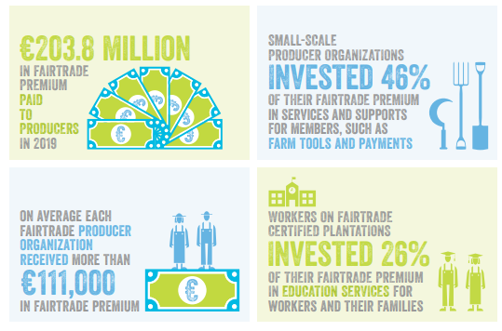

Graphic taken from Fairtrade Foundation Monitoring Report 12th edition. Access here.

Unfortunately due to our campus outlets remaining closed for the majority of the academic year, sales of Fairtrade items plummeted. Nonetheless we continue to supply Fairtrade tea and coffee as standard, including in hospitality and our Students Union, and have continued to stock a range of Fairtrade items where supply chains allow.
Fairtrade sales

Engagement
Though our on-campus engagement during Fairtrade Fortnight was limited, the implications of more virtual working allowed us to extend our reach beyond the community and even internationally. Below are some of the activities we held:
Fairtrade Fortnight: Fairtrade, the climate crisis and engagement
This was our flagship event during Fairtrade Fortnight as we were joined by Nilufar Verjee, Fairtrade Foundation's Director of Public Engagement, to explore how Fairtrade and the climate crisis link, and how we can further engage others with Fairtrade. Over 50 people from multiple universities and communities joined this intersectional session.

The feedback was fantastic with 100% of attendees feeling more able to tackle the climate and ecological crisis and 90% feeling more empowered or inspired to act to do so as a result of this event.
Community action
This year we became part of the Fairtrade Universities Network, a group of universities across the country who are committed to championing Fairtrade. The group has provided excellent opportunities for collaboration and innovation.

Through our Schools Liaison Team we also hosted a virtual workshop over Fairtrade Fortnight which was offered to local schools free for those who wish to explore Fairtrade with their students.
Social media use
We also aimed to raise awareness of Fairtrade through our social media. Bournemouth University’s Sustainability Team reached over 3,000 people through this while our Students Union posted daily about Fairtrade to their Instagram Stories as part of an educational prize draw activity. Our catering team, ran by Chartwells, also regularly post on their social media to promote Fairtrade throughout the year.
Moving forward

Despite the challenges of this academic year, it has given us time to plan some exciting activities to engage students with Fairtrade for the next year. We hope that as our campuses get fuller, we can return to offering our full range of Fairtrade products and continue with innovative campaigns and opportunities, including a student debate, training and in-person activities.

